COMP 469
Chapter 3 Speaker Notes
Solving Problems by Searching · Sections 3.1–3.4
CSU Channel Islands · COMP 469

Scope. These notes align to the revised Chapter 3 lecture deck and cover only Sections 3.1 through 3.4: problem-solving agents, example problems, search algorithms, and uninformed search strategies. Informed search, heuristics, greedy search, and A* are intentionally deferred to the next lecture.
How to use. The read-aloud teaching script under each slide is written in complete sentences. The teaching cue and transition lines are optional but are included to help with pacing and classroom delivery.

Deck Alignment and Pacing Map
Slide | Title | Suggested time
1 | COMP 469 Chapter 3: Solving Problems by Searching | 3–6 min
2 | Scope and Learning Targets | 3–6 min
3 | Why Search? Agents That Look Ahead | 3–6 min
4 | The Four-Phase Problem-Solving Process | 5–10 min
5 | Environment Assumptions: When a Fixed Plan Works | 3–6 min
6 | Section 3.1: Problem-Solving Agents | 3–6 min
7 | Formal Definition of a Search Problem | 3–6 min
8 | Paths, Solutions, and Optimality | 3–6 min
9 | Romania Route-Finding Example | 3–6 min
10 | Abstraction: Keep What Matters, Drop What Does Not | 3–6 min
11 | Section 3.2: Example Problems | 3–6 min
12 | Standardized vs. Real-World Problems | 5–10 min
13 | Grid Worlds and the Vacuum World | 3–6 min
14 | Other Standardized Problems | 3–6 min
15 | Real-World Problems | 3–6 min
16 | Section 3.3: Search Algorithms | 3–6 min
17 | State Space vs. Search Tree | 3–6 min
18 | Frontier, Reached, and Expansion | 3–6 min
19 | Best-First Search: One Engine, Many Strategies | 3–6 min
20 | Search Data Structures | 3–6 min
21 | Redundant Paths and Cycles | 3–6 min
22 | How We Evaluate Search Algorithms | 3–6 min
23 | Section 3.4: Uninformed Search Strategies | 3–6 min
24 | Breadth-First Search | 3–6 min
25 | BFS Complexity | 3–6 min
26 | Uniform-Cost Search | 3–6 min
27 | UCS Example: Sibiu to Bucharest | 3–6 min
28 | UCS Complexity and the Positive-Cost Assumption | 3–6 min
29 | Depth-First Search | 3–6 min
30 | DFS Failure Modes and Backtracking | 3–6 min
31 | Depth-Limited Search and Iterative Deepening | 3–6 min
32 | IDS Repetition | 3–6 min
33 | Bidirectional Search | 3–6 min
34 | Comparing Uninformed Search Algorithms | 3–6 min
35 | Class Demonstration: One Search Engine, Different Queues | 5–10 min
36 | Chapter 3.1–3.4 Takeaways | 3–6 min

Slide 1 — COMP 469 Chapter 3: Solving Problems by Searching
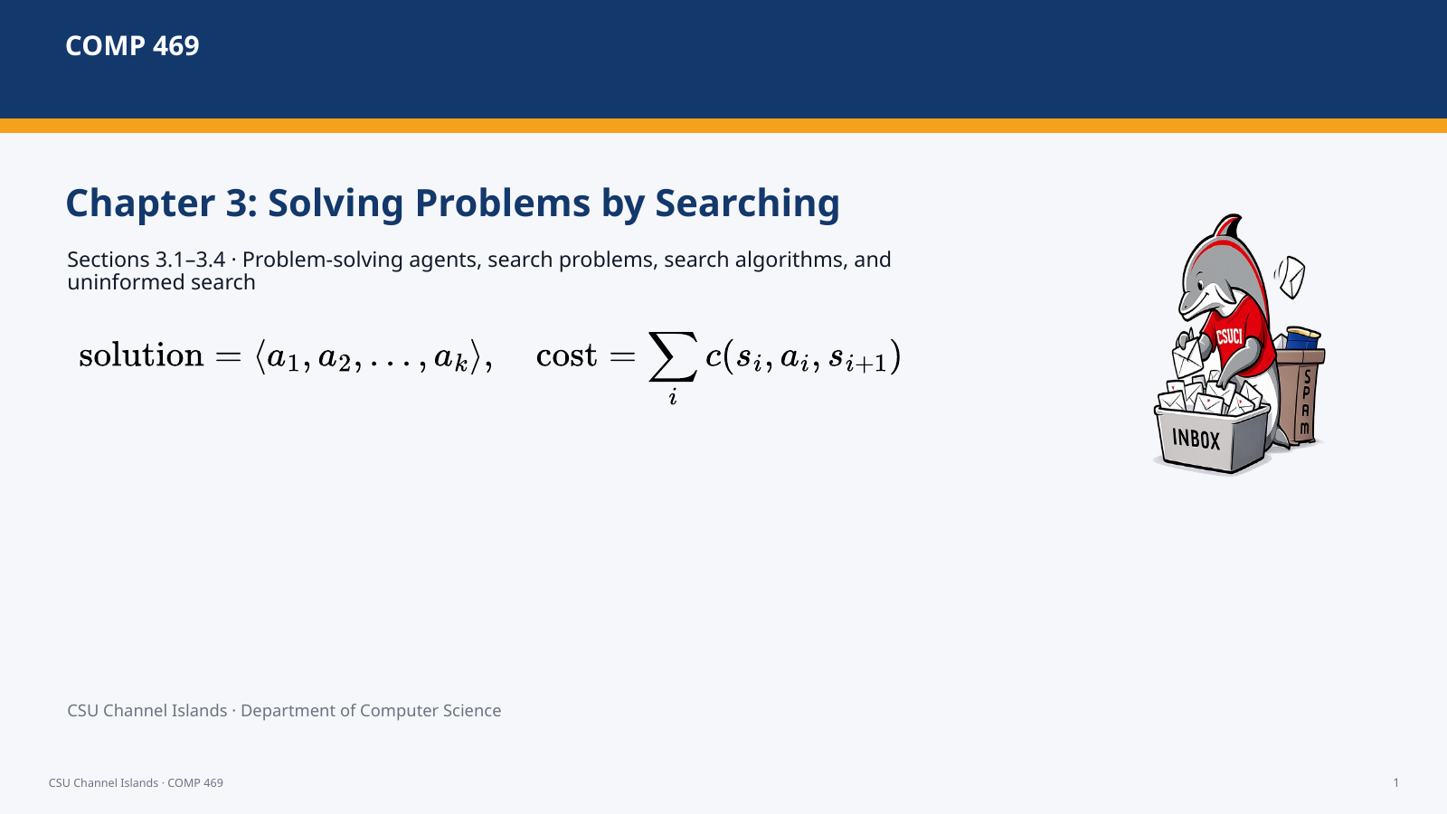 | Suggested time: 3–6 minutes  Teaching purpose: Open the lecture, state the scope, and separate this lecture from informed search.  Source alignment: AIMA Chapter 3, Sections 3.1–3.4; formulas and figures checked against the uploaded ODT file.

Read-aloud teaching script
Today we are covering Chapter 3, Sections 3.1 through 3.4 only. The theme is simple: when the next action is not obvious, an intelligent agent can look ahead. It can formulate a goal, build an abstract problem, search through possible action sequences, and then execute the solution. We are not yet using heuristics or A star. Those belong to informed search in the next lecture. Today we establish the formal search framework and the major uninformed strategies.
Teaching cue: Emphasize “3.1 to 3.4 only.” Students often jump straight to A star because they have heard of it; frame that as a later improvement.

Transition: We start by stating the specific learning outcomes for this lecture.

Slide 2 — Scope and Learning Targets
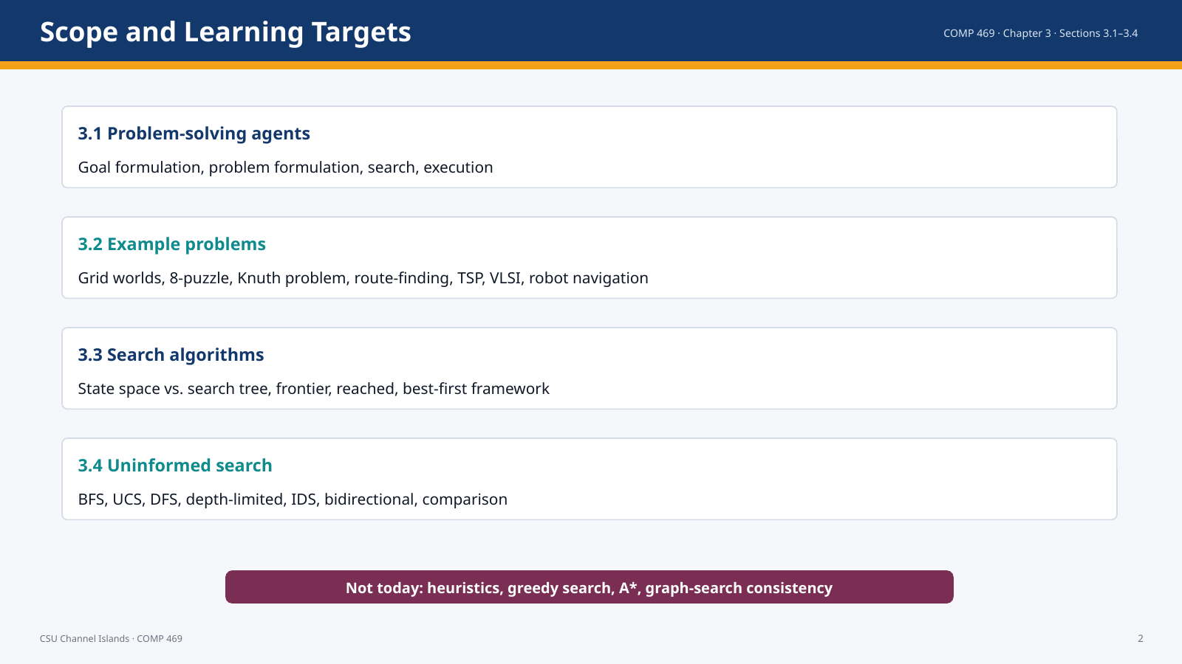 | Suggested time: 3–6 minutes  Teaching purpose: Clarify the chapter boundaries and the expected student takeaways.  Source alignment: AIMA Chapter 3, Sections 3.1–3.4; formulas and figures checked against the uploaded ODT file.

Read-aloud teaching script
This lecture is bounded intentionally. Section 3.1 gives us problem-solving agents and the formal definition of a search problem. Section 3.2 shows how that definition applies to benchmark problems and real-world problems. Section 3.3 explains search trees, frontiers, reached states, and the general best-first framework. Section 3.4 then compares uninformed search strategies. By the end, students should be able to formulate a problem, identify the data structures used by a search algorithm, and choose among breadth-first, uniform-cost, depth-first, depth-limited, iterative deepening, and bidirectional search.
Teaching cue: Point out that the existing deck previously emphasized informed search. This revised deck replaces that with the correct Chapter 3.1–3.4 scope.

Transition: Now we connect search back to Chapter 2’s goal-based agents.

Slide 3 — Why Search? Agents That Look Ahead
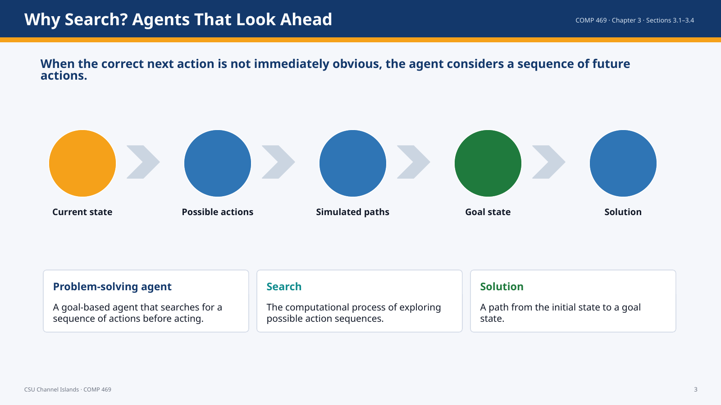 | Suggested time: 3–6 minutes  Teaching purpose: Explain why search is the next topic after intelligent agents.  Source alignment: AIMA Chapter 3, Sections 3.1–3.4; formulas and figures checked against the uploaded ODT file.

Read-aloud teaching script
A simple reflex agent reacts to the current percept. That is useful in some environments, but it fails when the agent must consider consequences. A problem-solving agent looks ahead. It imagines possible sequences of actions, checks whether any sequence reaches a goal, and then executes the solution. This is exactly the bridge from Chapter 2 to Chapter 3: a goal-based agent needs a way to choose the actions that achieve its goal. Search is that mechanism.
Teaching cue: Ask: “What is a task where one-step reaction is not enough?” Examples: route planning, puzzle solving, scheduling, circuit layout.

Transition: The chapter organizes this behavior into four phases.

Slide 4 — The Four-Phase Problem-Solving Process
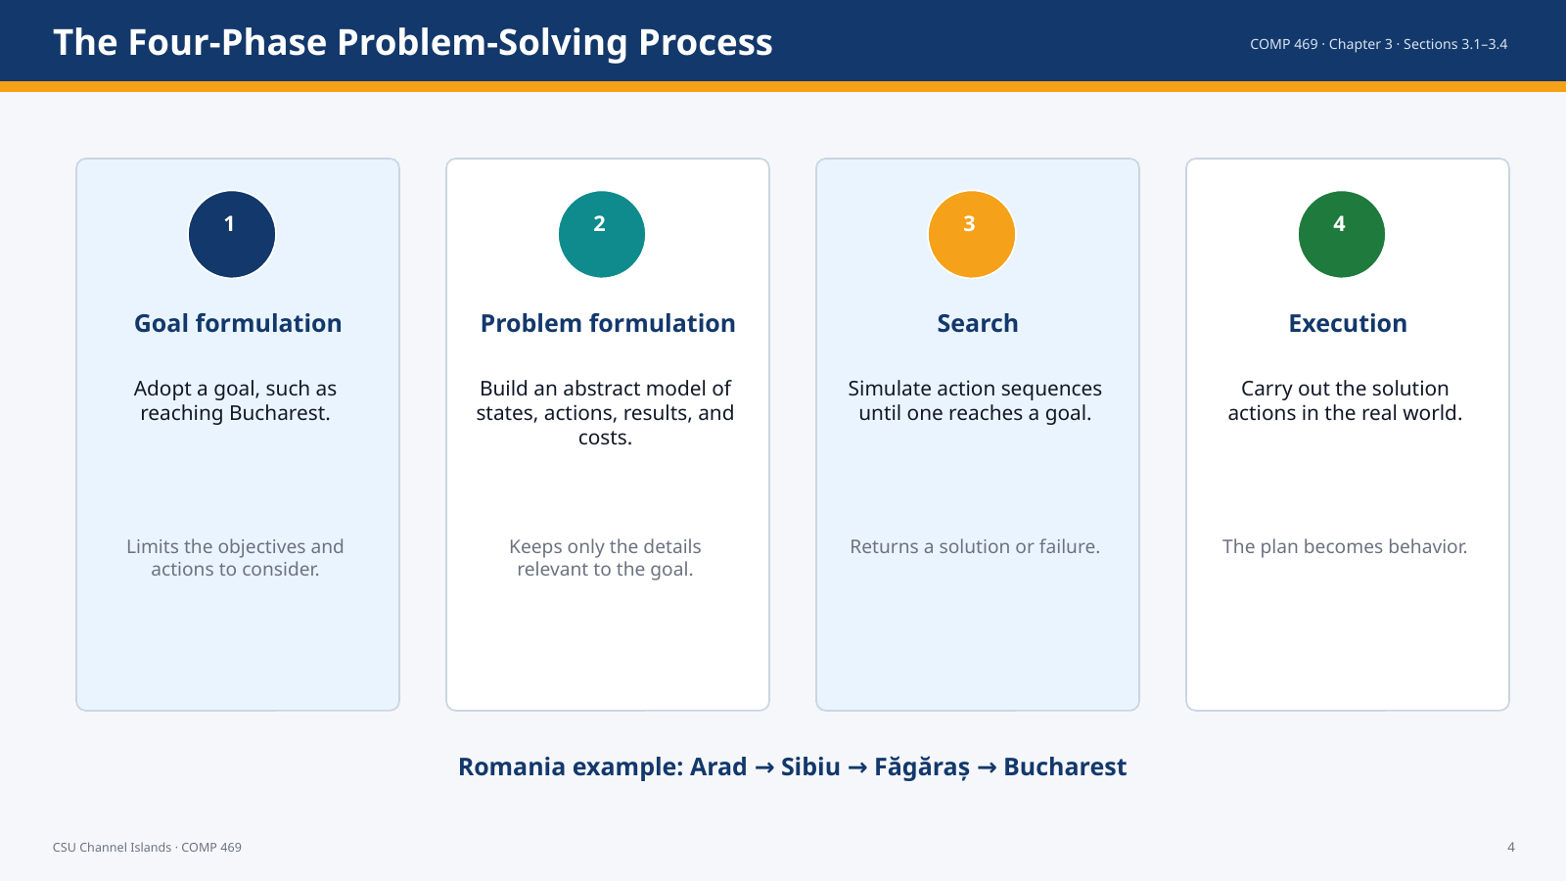 | Suggested time: 3–6 minutes  Teaching purpose: Present the major process from Section 3.1.  Source alignment: AIMA Chapter 3, Sections 3.1–3.4; formulas and figures checked against the uploaded ODT file.

Read-aloud teaching script
The chapter describes a four-phase process. First, the agent formulates a goal. In the Romania example, the goal is to reach Bucharest. Second, it formulates a problem by creating an abstract description of states and actions. Third, it searches in that model before acting in the real world. Fourth, it executes the actions in the solution one at a time. The important point is that search happens in a model. The agent does not have to physically try every road; it can simulate possible routes first.
Teaching cue: Pause on problem formulation: this is where bad abstractions make search impossible or useless.

Transition: The reliability of a fixed solution depends on the environment assumptions.

Slide 5 — Environment Assumptions: When a Fixed Plan Works
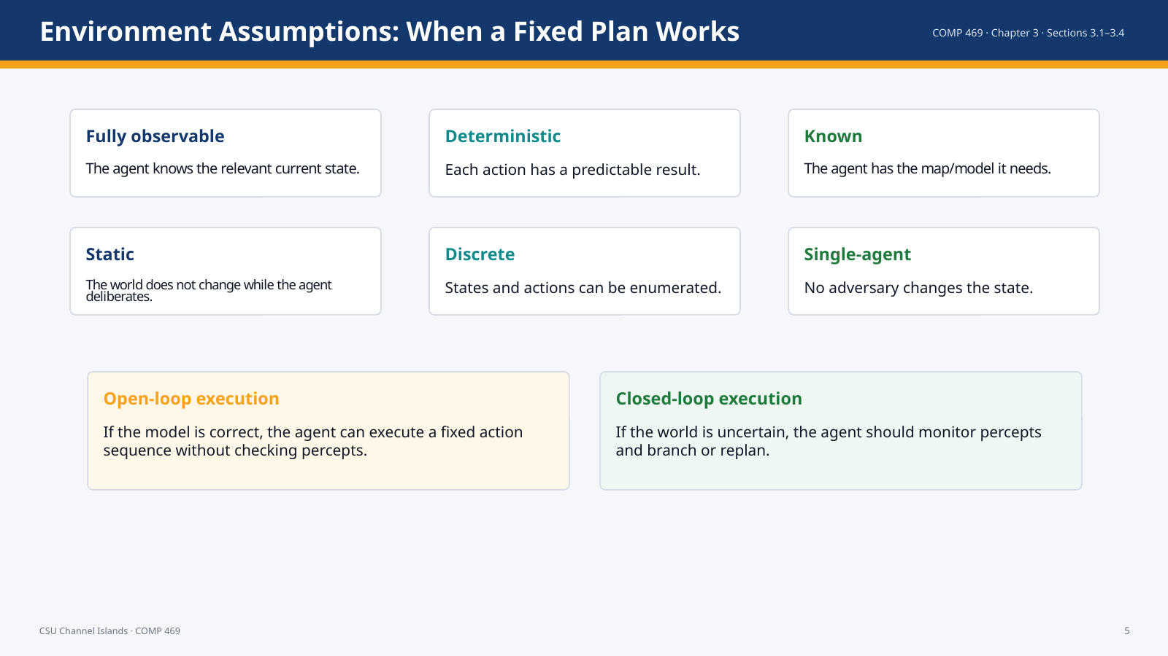 | Suggested time: 3–6 minutes  Teaching purpose: Explain the simplifying assumptions of Sections 3.1–3.4 and the open-loop idea.  Source alignment: AIMA Chapter 3, Sections 3.1–3.4; formulas and figures checked against the uploaded ODT file.

Read-aloud teaching script
For Sections 3.1 through 3.4, the chapter assumes relatively simple environments: fully observable, deterministic, known, static, discrete, and single-agent. Under those assumptions, a solution can be a fixed sequence of actions. Once the agent finds the route Arad to Sibiu to Fagaras to Bucharest, it can execute that route as an open-loop plan. If the model might be wrong, or if the world is nondeterministic, open-loop execution becomes risky. Then the agent needs a closed-loop strategy that checks percepts and replans or branches.
Teaching cue: Connect this back to Chapter 2 environment properties.

Transition: Next we define the formal pieces of a search problem.

Slide 6 — Section 3.1: Problem-Solving Agents
 | Suggested time: 3–6 minutes  Teaching purpose: Mark the beginning of Section 3.1.  Source alignment: AIMA Chapter 3, Sections 3.1–3.4; formulas and figures checked against the uploaded ODT file.

Read-aloud teaching script
We now begin Section 3.1. This section gives the formal vocabulary for problem-solving agents and search problems. The vocabulary matters because every algorithm in the rest of the chapter uses these same components.
Teaching cue: Use this as a brief reset slide.

Transition: The first formal object is the search problem.

Slide 7 — Formal Definition of a Search Problem
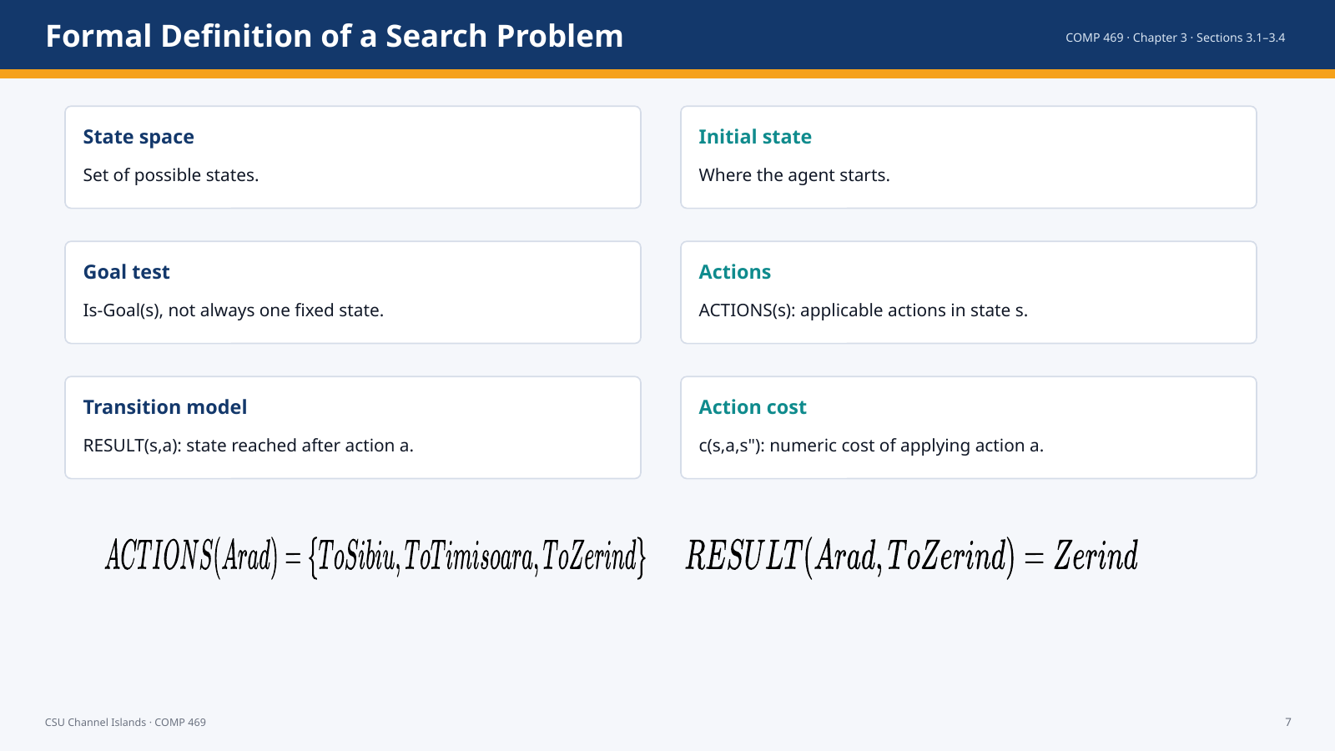 | Suggested time: 3–6 minutes  Teaching purpose: Define the six components of a search problem.  Source alignment: AIMA Chapter 3, Sections 3.1–3.4; formulas and figures checked against the uploaded ODT file.

Read-aloud teaching script
A search problem is not just a story. It has a formal structure. We need a state space, an initial state, a goal test, a set of available actions, a transition model, and an action cost function. In the Romania example, the state space is the set of cities, the initial state might be Arad, the goal test checks whether the state is Bucharest, actions are roads to adjacent cities, the transition model tells us which city the action leads to, and the action cost can be distance or time.
Teaching cue: Emphasize that Is-Goal can describe a property, not just one named state.

Transition: Once we have this definition, we can talk about paths and optimality.

Slide 8 — Paths, Solutions, and Optimality
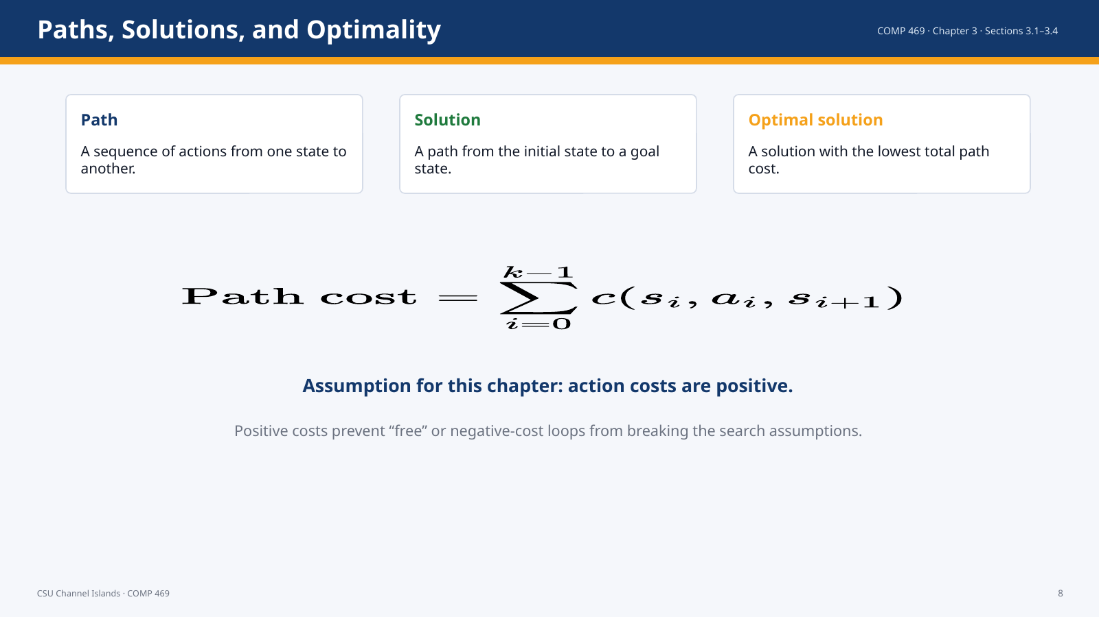 | Suggested time: 3–6 minutes  Teaching purpose: Clarify path cost and optimality using correct mathematical notation.  Source alignment: AIMA Chapter 3, Sections 3.1–3.4; formulas and figures checked against the uploaded ODT file.

Read-aloud teaching script
A sequence of actions forms a path. A solution is a path that starts at the initial state and reaches a goal state. An optimal solution is the solution with the lowest path cost. In this chapter, the path cost is additive, so the total cost is the sum of the individual action costs along the path. The positive-cost assumption is important because zero-cost or negative-cost loops would create complications for the algorithms and their optimality claims.
Teaching cue: This slide fixes the formulas by showing them as equations rather than raw text.

Transition: Now we apply those definitions to the Romania map.

Slide 9 — Romania Route-Finding Example
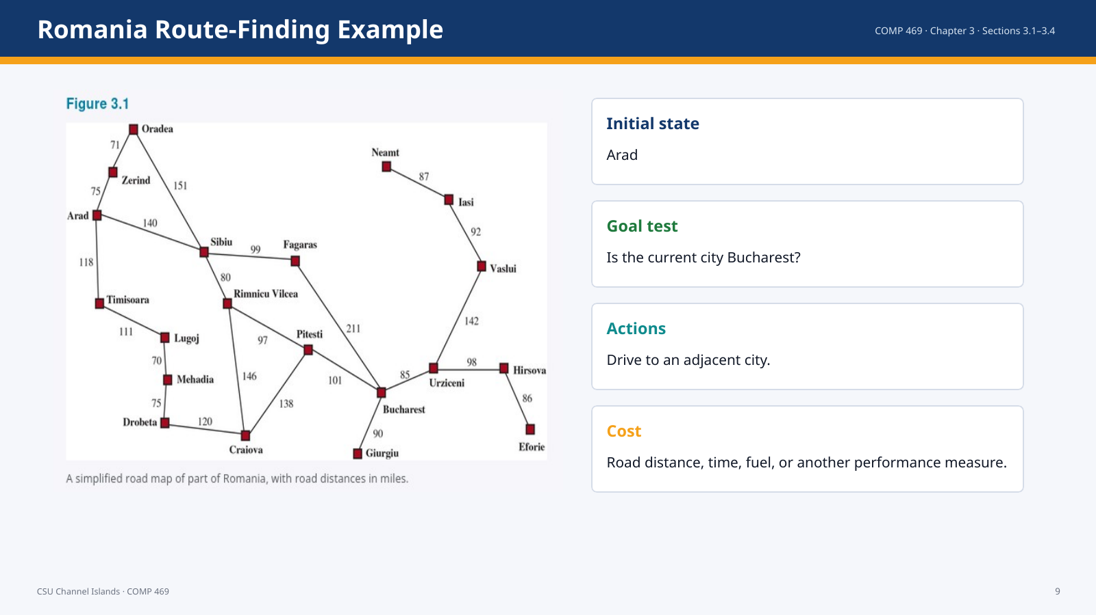 | Suggested time: 3–6 minutes  Teaching purpose: Use the canonical map example to ground the formal search definition.  Source alignment: AIMA Chapter 3, Sections 3.1–3.4; formulas and figures checked against the uploaded ODT file.

Read-aloud teaching script
The Romania example is useful because the state space is easy to see. Each city is a state, and each road gives two possible actions, one in each direction. A route is a path through the graph. For example, Arad to Sibiu to Rimnicu Vilcea to Pitesti to Bucharest is a path. If the cost function is road distance, we can compare route costs and ask which solution is optimal.
Teaching cue: Point to the map while naming Arad, Sibiu, Fagaras, Pitesti, and Bucharest.

Transition: The map is already an abstraction; the next slide explains why abstraction matters.

Slide 10 — Abstraction: Keep What Matters, Drop What Does Not
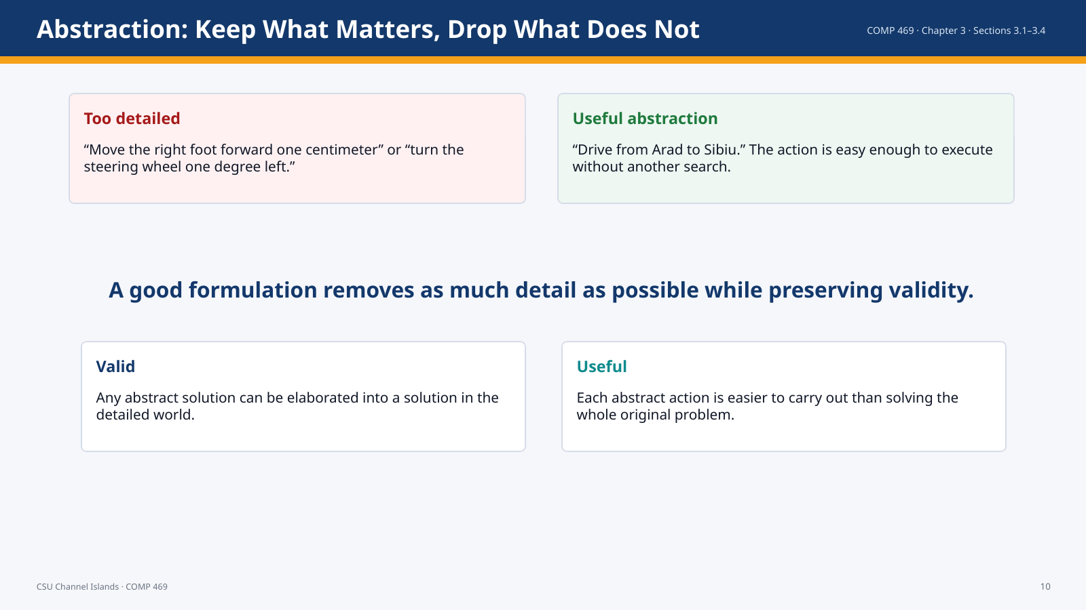 | Suggested time: 3–6 minutes  Teaching purpose: Explain problem formulation as abstraction.  Source alignment: AIMA Chapter 3, Sections 3.1–3.4; formulas and figures checked against the uploaded ODT file.

Read-aloud teaching script
A search problem is an abstraction of the real world. In route planning, the state may be just the current city, not the weather, the radio station, the seat position, or the scenery. A good abstraction keeps the details that affect the solution and removes details that do not. The abstraction must be valid, meaning an abstract solution can be turned into a real solution. It must also be useful, meaning each abstract action is manageable without doing the entire search again.
Teaching cue: Ask: “What details would you omit from a campus pathfinding model?”

Transition: Section 3.2 shows examples of problems that can be formulated this way.

Slide 11 — Section 3.2: Example Problems
 | Suggested time: 3–6 minutes  Teaching purpose: Transition to standardized and real-world search problems.  Source alignment: AIMA Chapter 3, Sections 3.1–3.4; formulas and figures checked against the uploaded ODT file.

Read-aloud teaching script
Section 3.2 shows that the same formal search vocabulary applies to many different domains. Some examples are standardized benchmarks. Others are real-world problems with messy specifications. The goal is for students to see that search is not only a map algorithm; it is a general way of representing a problem as states, actions, transitions, goals, and costs.
Transition: We start with the distinction between benchmark problems and real-world problems.

Slide 12 — Standardized vs. Real-World Problems
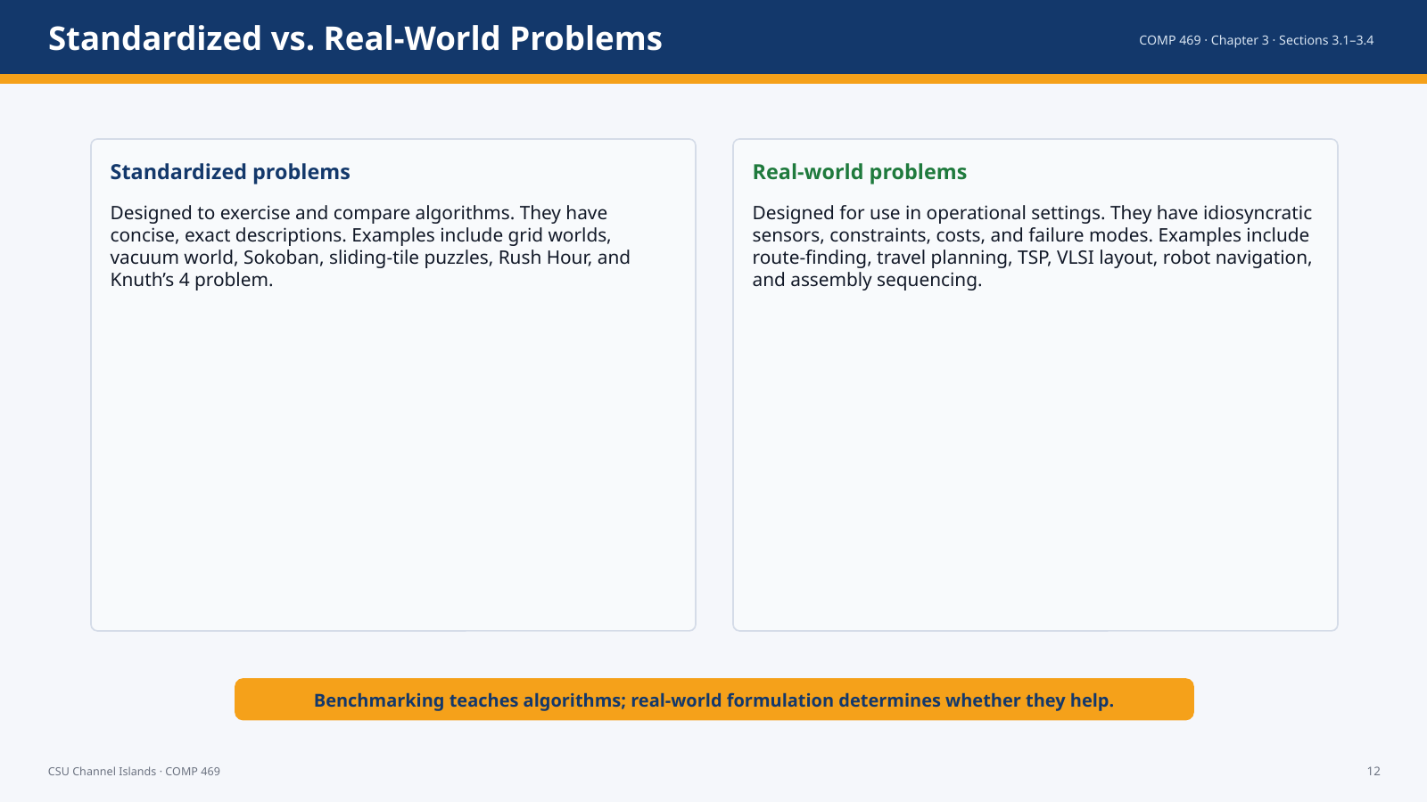 | Suggested time: 3–6 minutes  Teaching purpose: Distinguish classroom benchmarks from operational search applications.  Source alignment: AIMA Chapter 3, Sections 3.1–3.4; formulas and figures checked against the uploaded ODT file.

Read-aloud teaching script
The chapter separates standardized problems from real-world problems. Standardized problems are useful because they are precise, compact, and comparable. Researchers can test algorithms on the same problem definition. Real-world problems are messier. The formulation depends on the sensors, actuators, constraints, costs, and risks of the system. In practice, much of the work is not only choosing a search algorithm; it is deciding what should count as a state, an action, a goal, and a cost.
Transition: Next we look at grid worlds and the vacuum world because they make state-space growth visible.

Slide 13 — Grid Worlds and the Vacuum World
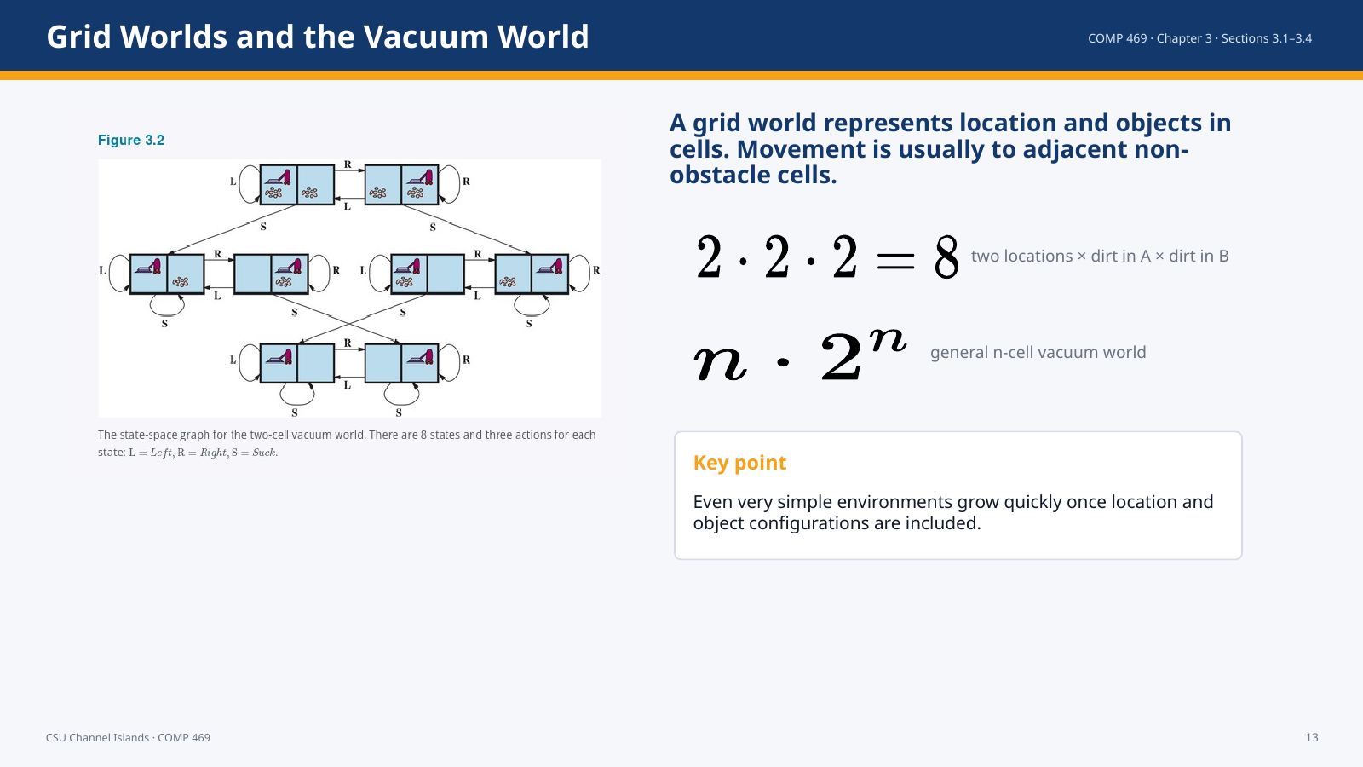 | Suggested time: 3–6 minutes  Teaching purpose: Show the state-space count formulas correctly and explain combinatorial growth.  Source alignment: AIMA Chapter 3, Sections 3.1–3.4; formulas and figures checked against the uploaded ODT file.

Read-aloud teaching script
In a grid world, the agent moves through cells and interacts with objects in cells. The two-cell vacuum world is a small example: the agent can be in either location, and each location can be clean or dirty. That gives two times two times two, or eight states. More generally, an n-cell vacuum world has n possible agent locations and two-to-the-n possible dirt configurations, for n times two-to-the-n states. This formula is small enough to understand but large enough to show why search complexity matters.
Teaching cue: Call attention to the equations; these are intentionally rendered as math, not raw LaTeX.

Transition: Other standardized problems grow even faster.

Slide 14 — Other Standardized Problems
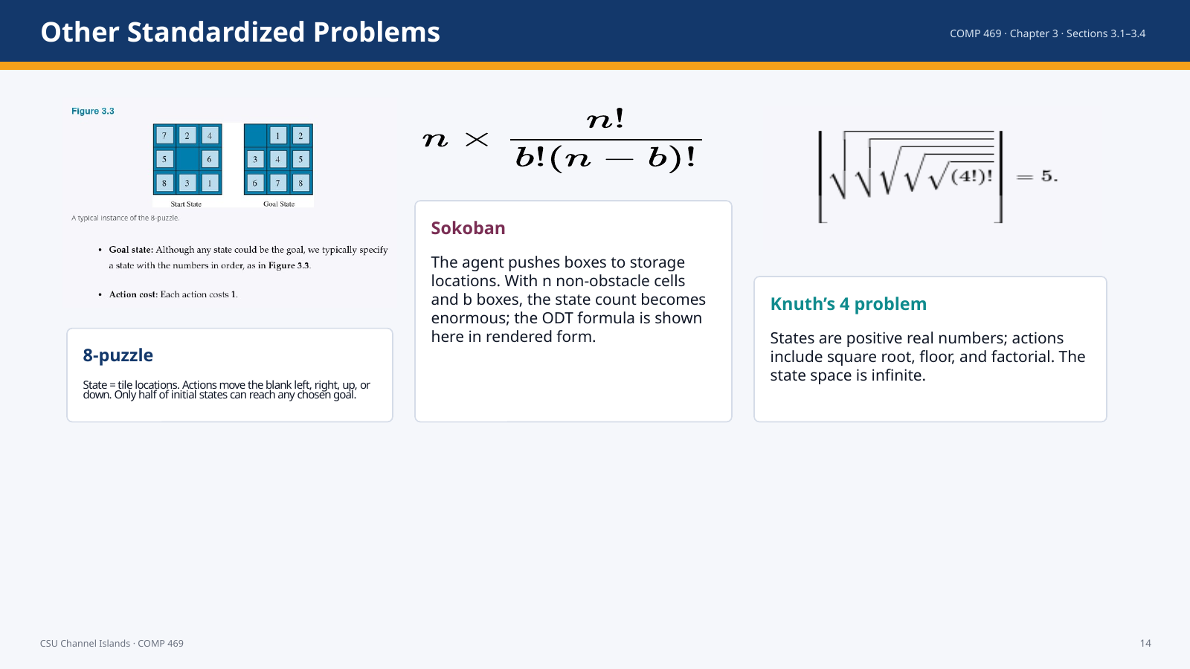 | Suggested time: 3–6 minutes  Teaching purpose: Extend standardized examples and preserve formulas from the ODT.  Source alignment: AIMA Chapter 3, Sections 3.1–3.4; formulas and figures checked against the uploaded ODT file.

Read-aloud teaching script
Sokoban, the 8-puzzle, and Knuth’s 4 problem show different types of difficulty. The 8-puzzle is discrete and finite, but the parity property means only half the initial states can reach a fixed goal. Sokoban is a grid world, but box positions cause an enormous state space. Knuth’s problem shows that state spaces can be infinite. The shortest path to five from four passes through a very large factorial expression.
Teaching cue: The formula on the slide is rendered as math so students see the correct combinatorial expression.

Transition: Now we shift to real-world examples.

Slide 15 — Real-World Problems
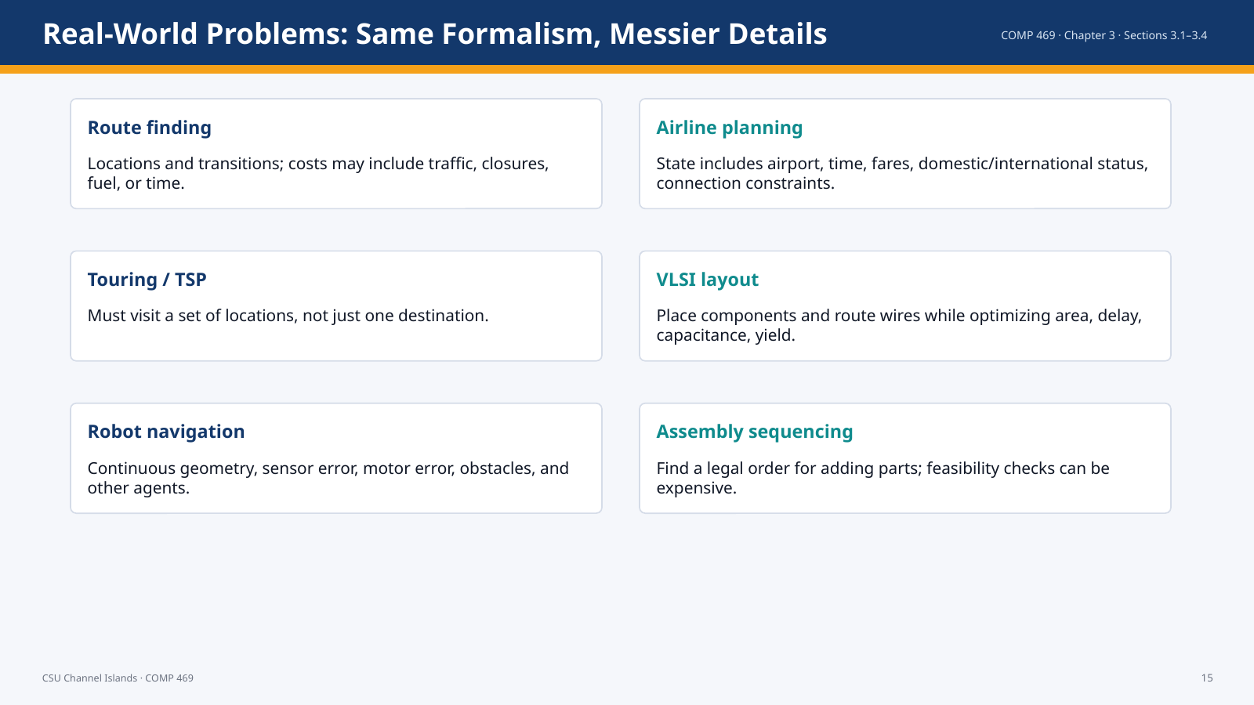 | Suggested time: 3–6 minutes  Teaching purpose: Show that the search model applies beyond textbook puzzles.  Source alignment: AIMA Chapter 3, Sections 3.1–3.4; formulas and figures checked against the uploaded ODT file.

Read-aloud teaching script
Real-world search problems use the same formal pieces, but their formulation is more complicated. Airline planning states include not only location but also time and fare history. Touring problems require visiting multiple locations. VLSI layout involves millions of components and constraints. Robot navigation may require discretizing a continuous physical space. Assembly sequencing requires checking whether parts can actually be added in a proposed order. The theme is the same: define states, actions, goals, transition model, and cost carefully.
Transition: The next section explains how algorithms search over those problem formulations.

Slide 16 — Section 3.3: Search Algorithms
 | Suggested time: 3–6 minutes  Teaching purpose: Transition from problem formulation to the mechanics of search.  Source alignment: AIMA Chapter 3, Sections 3.1–3.4; formulas and figures checked against the uploaded ODT file.

Read-aloud teaching script
Section 3.3 explains how algorithms operate once a problem has been formulated. The core structure is a search tree superimposed on a state-space graph. Students need to distinguish those two objects before comparing algorithms.
Transition: We begin by contrasting the state space with the search tree.

Slide 17 — State Space vs. Search Tree
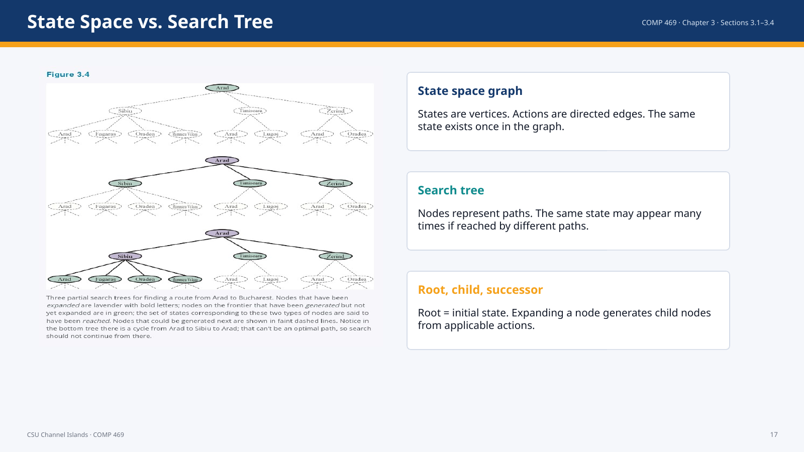 | Suggested time: 3–6 minutes  Teaching purpose: Explain the distinction between states and search-tree nodes.  Source alignment: AIMA Chapter 3, Sections 3.1–3.4; formulas and figures checked against the uploaded ODT file.

Read-aloud teaching script
The state space graph describes the world: states and transitions. The search tree describes paths through that world. This distinction is essential. One city, such as Sibiu, can appear once in the state space but many times in the search tree if there are multiple routes to reach it. Search algorithms do not simply walk around the map; they build and manage a tree of possible paths.
Teaching cue: Use the figure to point out repeated states in the tree.

Transition: The set of waiting nodes is called the frontier.

Slide 18 — Frontier, Reached, and Expansion
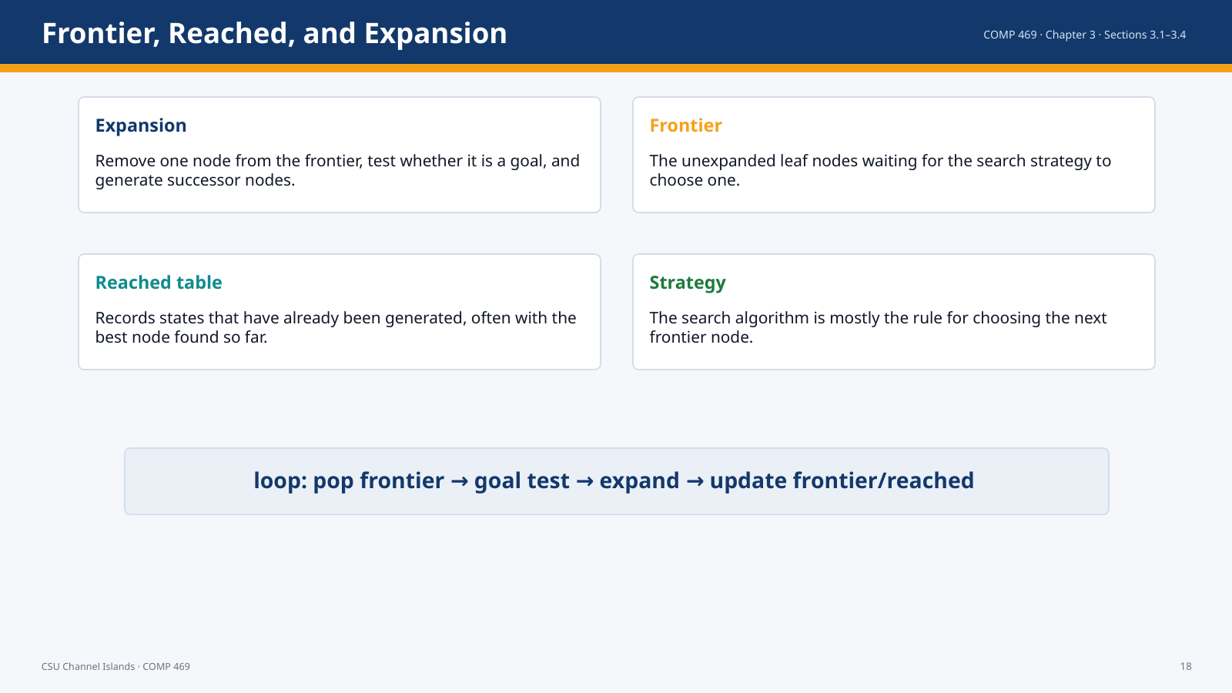 | Suggested time: 3–6 minutes  Teaching purpose: Define the dynamic data structures used by search algorithms.  Source alignment: AIMA Chapter 3, Sections 3.1–3.4; formulas and figures checked against the uploaded ODT file.

Read-aloud teaching script
The frontier is the set of generated but unexpanded nodes. The algorithm repeatedly chooses a node from the frontier, tests or expands it, and adds successors. The reached table records which states have already been generated, usually with the best node found so far for each state. Different search algorithms mostly differ in how they choose the next frontier node.
Teaching cue: Point out that “frontier” is not the same as “unvisited states”; it is the boundary of the search tree.

Transition: The most general version in this chapter is best-first search.

Slide 19 — Best-First Search: One Engine, Many Strategies
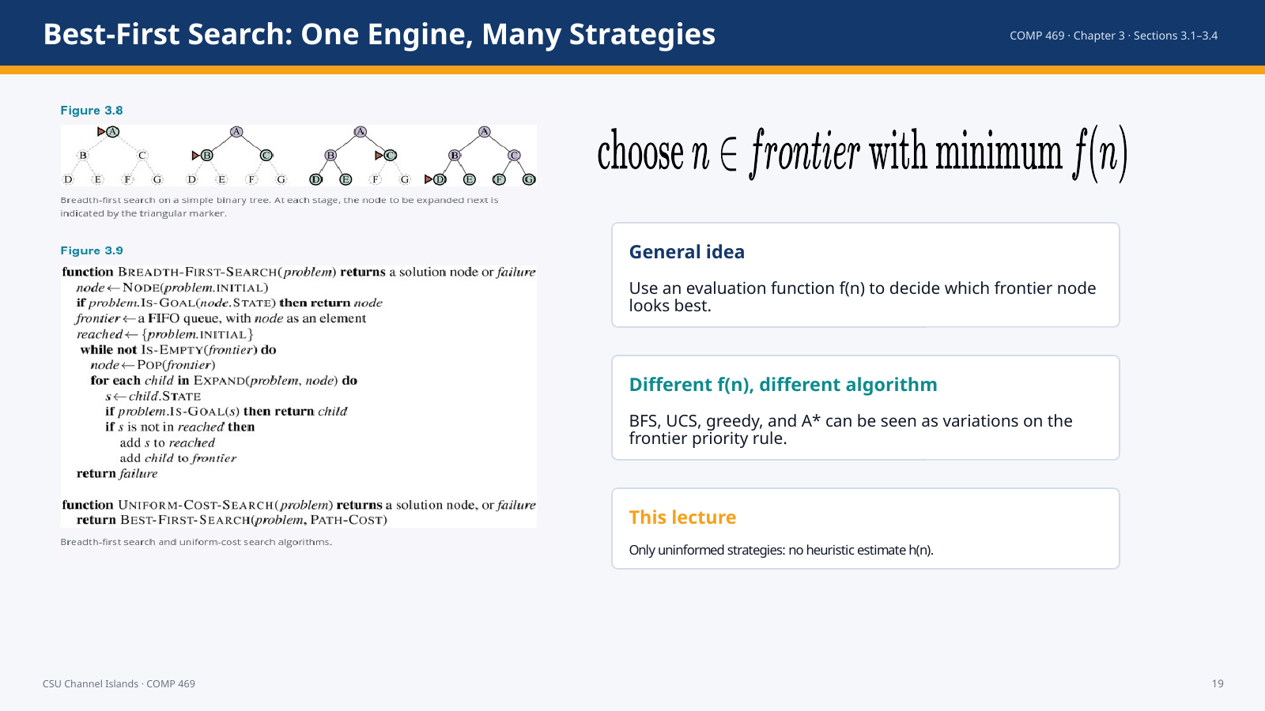 | Suggested time: 3–6 minutes  Teaching purpose: Introduce best-first search and f(n) without moving into informed search.  Source alignment: AIMA Chapter 3, Sections 3.1–3.4; formulas and figures checked against the uploaded ODT file.

Read-aloud teaching script
Best-first search is a general framework. It keeps a frontier and chooses a node with minimum value according to an evaluation function f of n. Different choices of f produce different algorithms. Uniform-cost search uses path cost. Greedy search and A star also fit this framework, but those are outside today’s scope because they require heuristic estimates. In this lecture we will use the framework mainly to understand breadth-first search, uniform-cost search, and the role of queues.
Teaching cue: Call attention to f(n) as a general priority function, not yet A star.

Transition: Search algorithms need concrete data structures.

Slide 20 — Search Data Structures
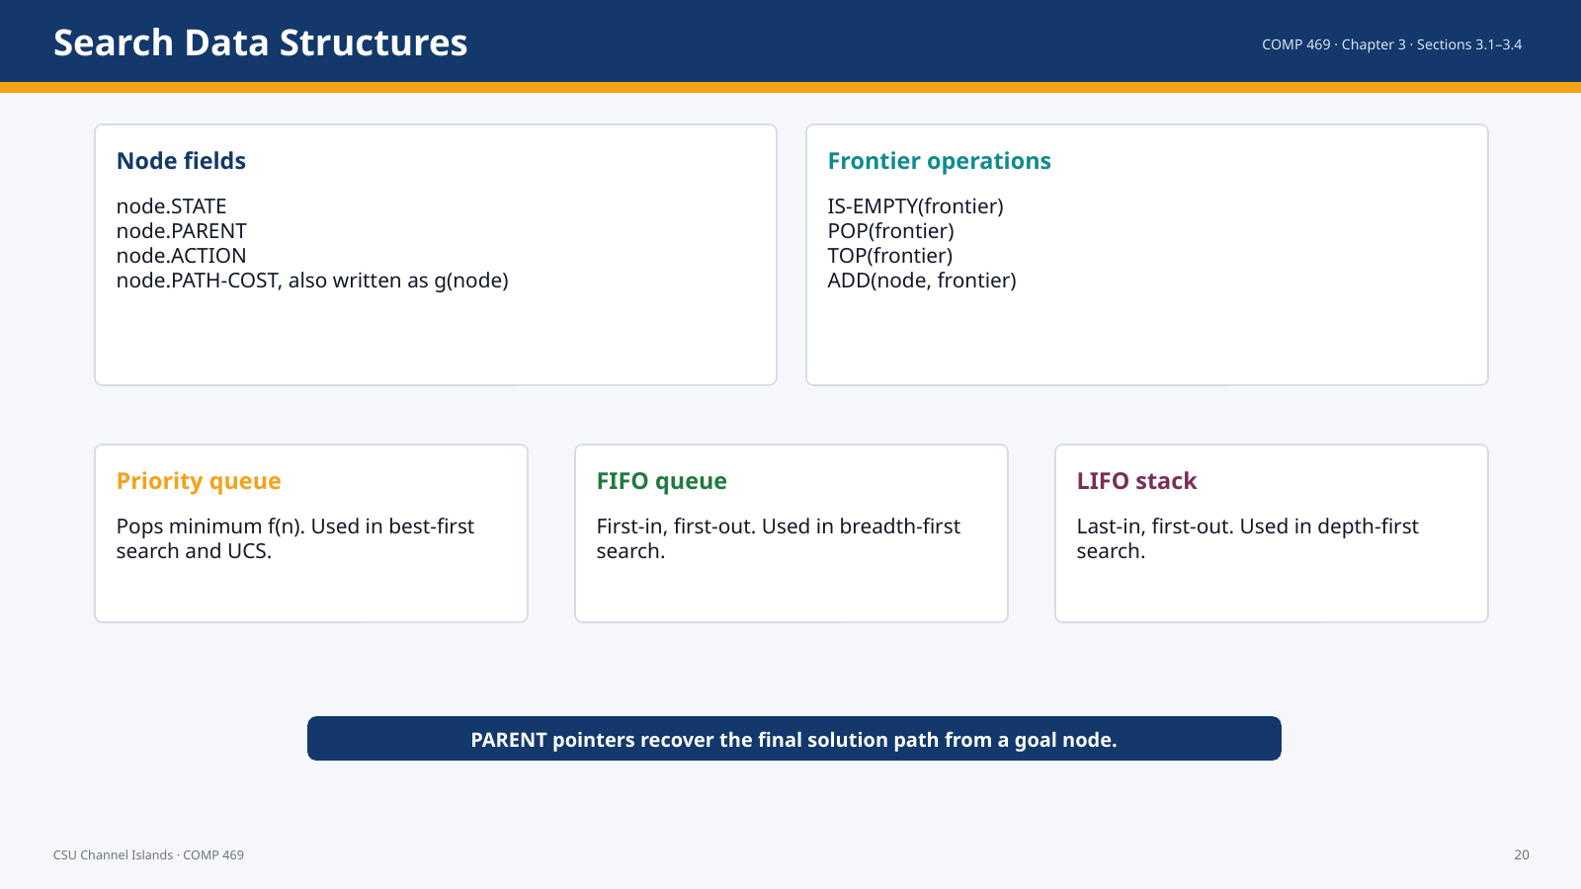 | Suggested time: 3–6 minutes  Teaching purpose: Define nodes, frontier operations, and queue types.  Source alignment: AIMA Chapter 3, Sections 3.1–3.4; formulas and figures checked against the uploaded ODT file.

Read-aloud teaching script
A search node stores the current state, the parent node, the action that produced it, and the path cost from the initial state. The parent pointers let us reconstruct the solution path when a goal is found. The frontier is stored as a queue-like data structure. A priority queue pops the minimum-priority node. A FIFO queue pops the oldest node. A LIFO stack pops the newest node. Much of uninformed search is just changing this data structure and priority rule.
Transition: Redundant paths are the reason reached states matter.

Slide 21 — Redundant Paths and Cycles
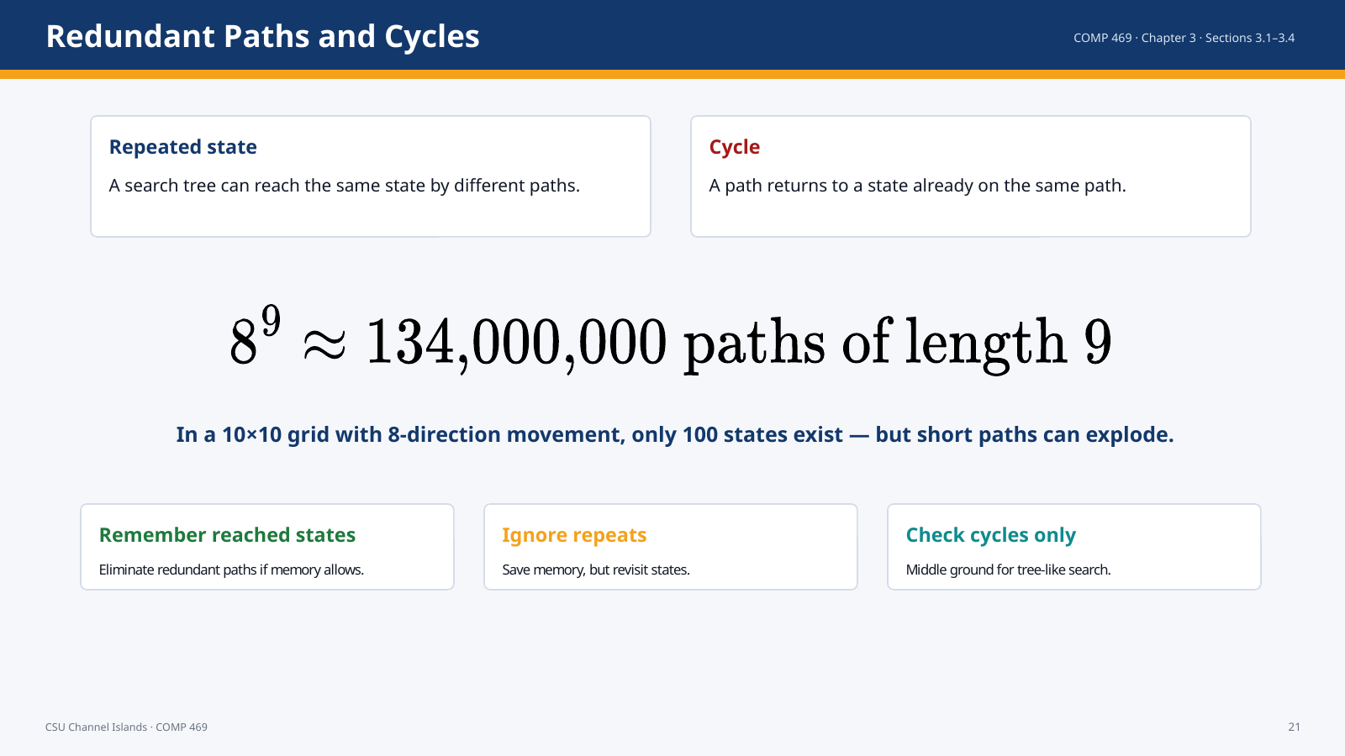 | Suggested time: 3–6 minutes  Teaching purpose: Explain why algorithms need reached tables or cycle checks.  Source alignment: AIMA Chapter 3, Sections 3.1–3.4; formulas and figures checked against the uploaded ODT file.

Read-aloud teaching script
The search tree can be much larger than the state space. A repeated state occurs when two different paths reach the same state. A cycle occurs when a path loops back to a state already on that path. The chapter gives the 10 by 10 grid example: there are only 100 cells, but there can be more than 100 million paths of length nine. If we remember reached states, we can eliminate redundant work. If we do not, the algorithm may repeat itself extensively.
Teaching cue: Use the phrase from the chapter: algorithms that cannot remember the past are doomed to repeat it.

Transition: Now we need criteria to compare algorithms.

Slide 22 — How We Evaluate Search Algorithms
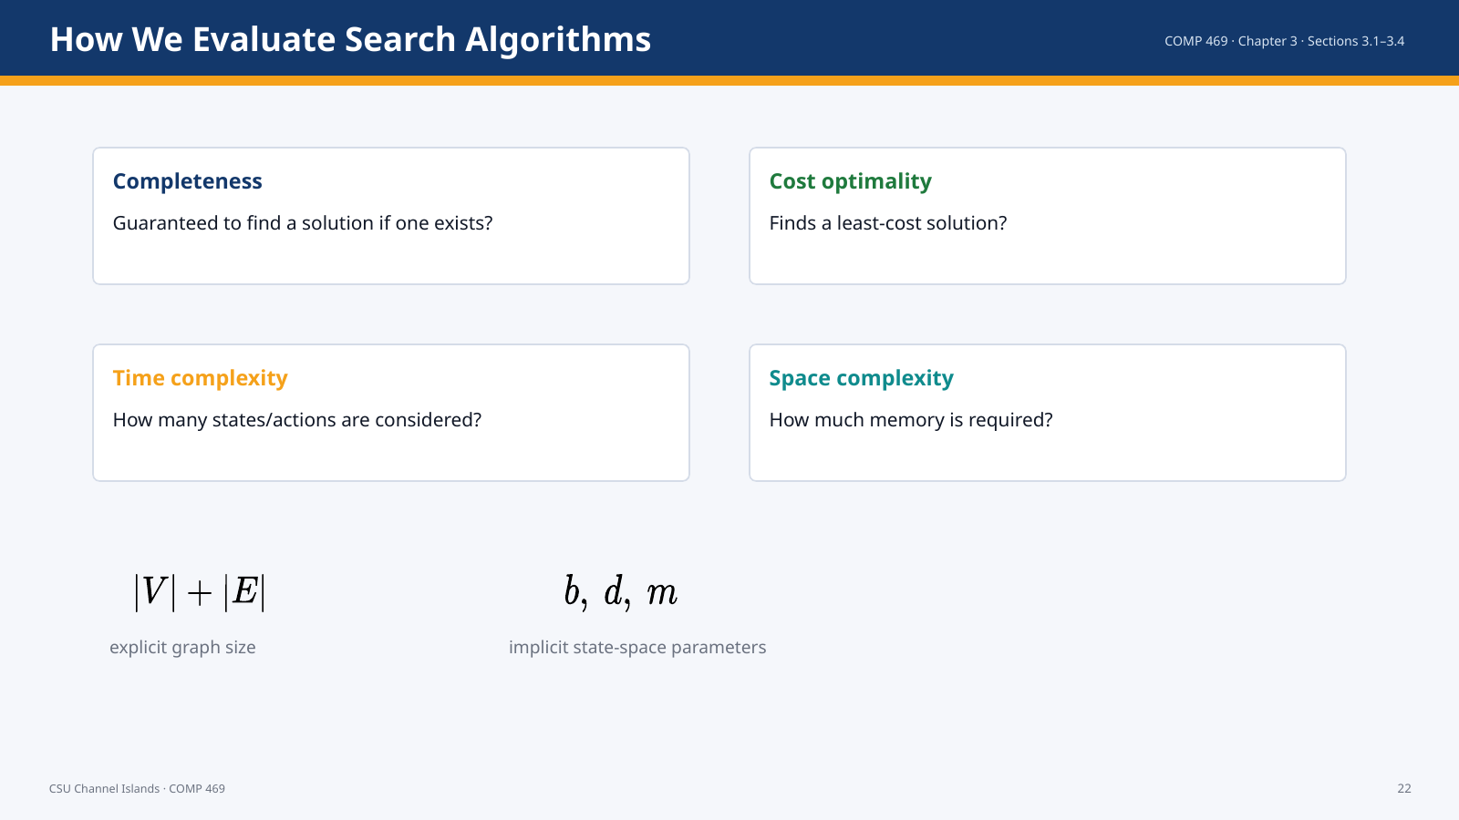 | Suggested time: 3–6 minutes  Teaching purpose: Introduce the four evaluation criteria and complexity parameters.  Source alignment: AIMA Chapter 3, Sections 3.1–3.4; formulas and figures checked against the uploaded ODT file.

Read-aloud teaching script
We compare search algorithms using completeness, cost optimality, time complexity, and space complexity. Completeness asks whether the algorithm is guaranteed to find a solution when one exists. Cost optimality asks whether it finds the cheapest solution. Time complexity measures how long it takes, often in generated or expanded nodes. Space complexity measures memory requirements. For explicit graphs, complexity may be described with the number of vertices and edges. For implicit AI problems, we often use b for branching factor, d for solution depth, and m for maximum path depth.
Transition: Now we move to Section 3.4: uninformed search.

Slide 23 — Section 3.4: Uninformed Search Strategies
 | Suggested time: 3–6 minutes  Teaching purpose: Transition into BFS, UCS, DFS, depth-limited, iterative deepening, and bidirectional search.  Source alignment: AIMA Chapter 3, Sections 3.1–3.4; formulas and figures checked against the uploaded ODT file.

Read-aloud teaching script
An uninformed search algorithm has no estimate of how close a state is to the goal. It knows the states it has reached, the actions available, the transition model, the costs, and the goal test. It does not know whether one unexpanded state is geographically or semantically closer to the goal unless that information is already encoded in path cost.
Transition: The first uninformed strategy is breadth-first search.

Slide 24 — Breadth-First Search
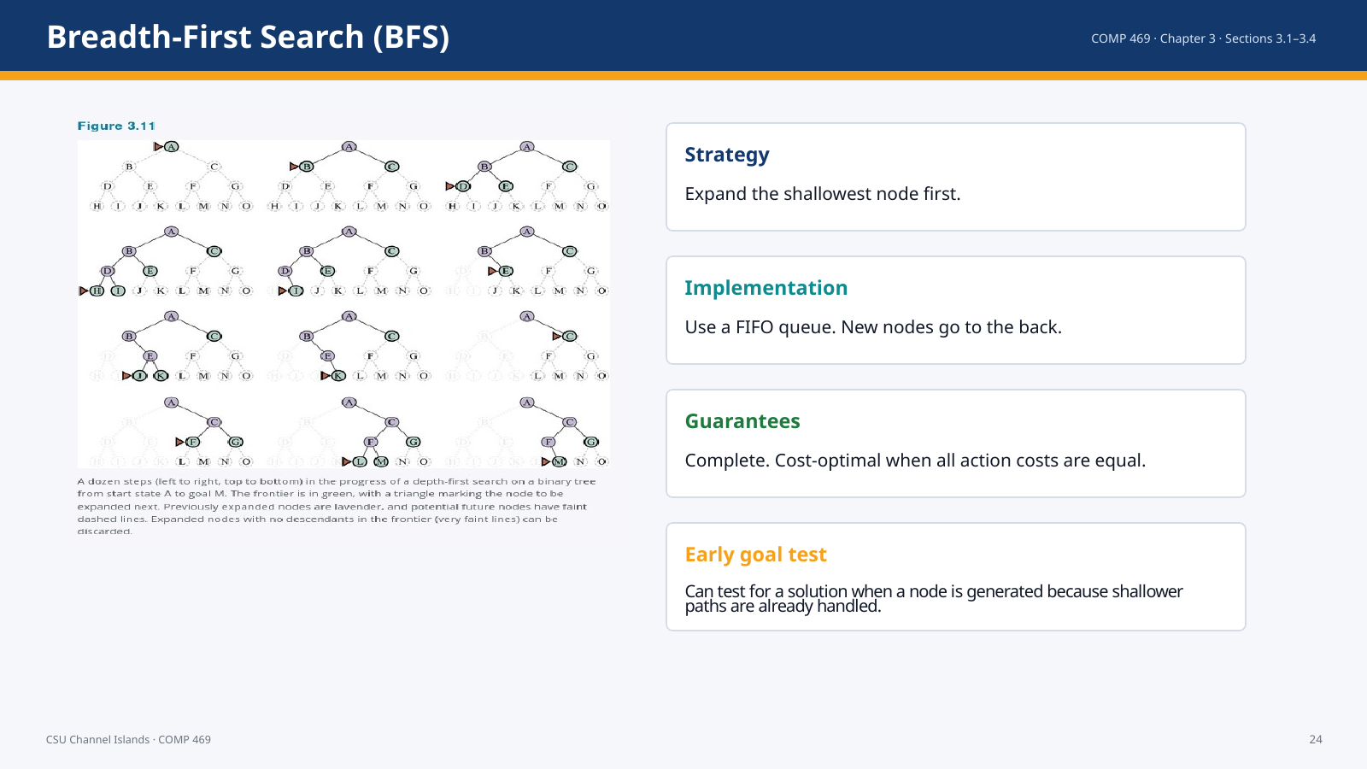 | Suggested time: 3–6 minutes  Teaching purpose: Explain BFS strategy, queue implementation, and guarantees.  Source alignment: AIMA Chapter 3, Sections 3.1–3.4; formulas and figures checked against the uploaded ODT file.

Read-aloud teaching script
Breadth-first search expands the root, then all nodes at depth one, then all nodes at depth two, and so on. A FIFO queue gives exactly this behavior because older, shallower nodes are popped before newer, deeper nodes. BFS is complete. It finds a solution with the fewest actions, and it is cost-optimal when every action has the same cost. If action costs differ, fewest actions is not necessarily cheapest.
Teaching cue: Ask students to predict which layer expands next.

Transition: The main weakness of BFS is memory.

Slide 25 — BFS Complexity
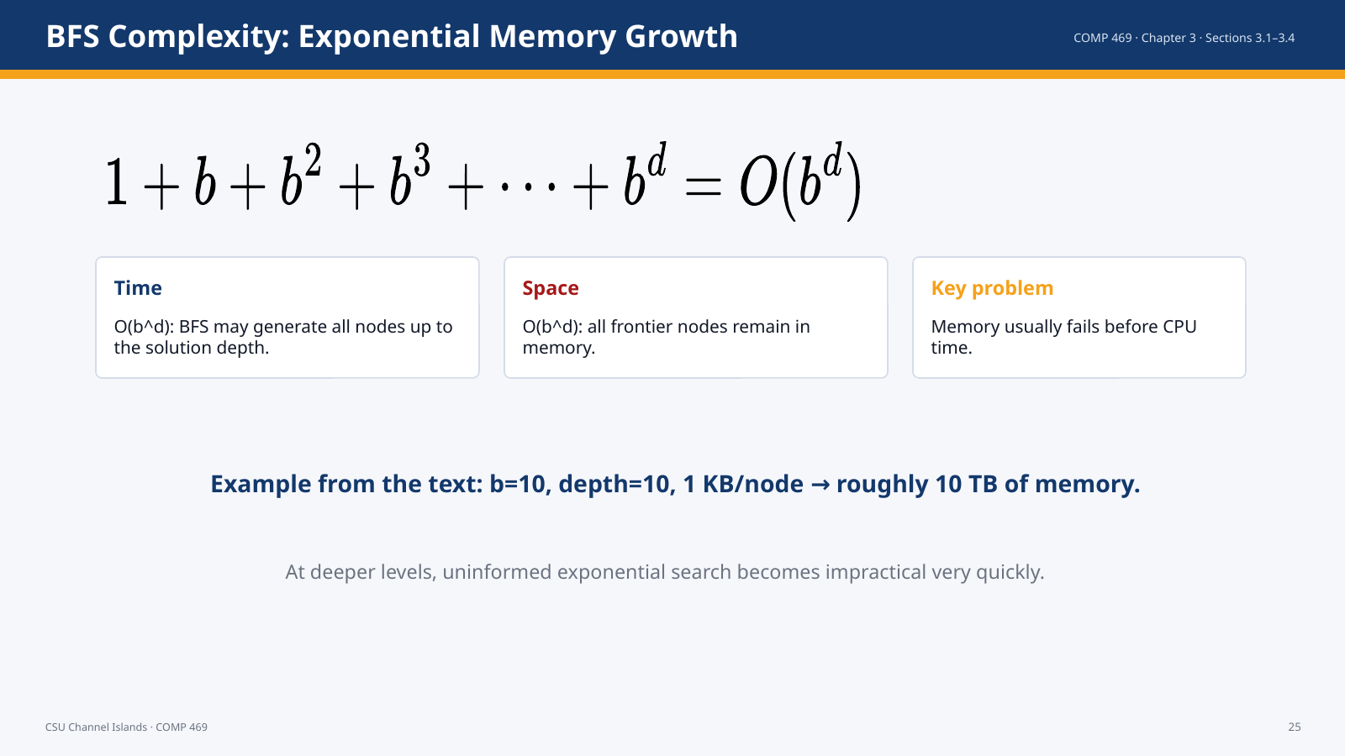 | Suggested time: 3–6 minutes  Teaching purpose: Show the correct BFS growth formula and stress the memory bottleneck.  Source alignment: AIMA Chapter 3, Sections 3.1–3.4; formulas and figures checked against the uploaded ODT file.

Read-aloud teaching script
For branching factor b and solution depth d, the number of generated nodes grows as one plus b plus b squared and so on up to b to the d. This is O of b to the d. The same exponential growth applies to space because BFS keeps all generated frontier nodes in memory. The text gives a practical example: at branching factor ten and depth ten, memory can already reach roughly ten terabytes if each node takes one kilobyte. This is why BFS is simple and reliable but not scalable for large problems.
Transition: If action costs vary, we need uniform-cost search.

Slide 26 — Uniform-Cost Search
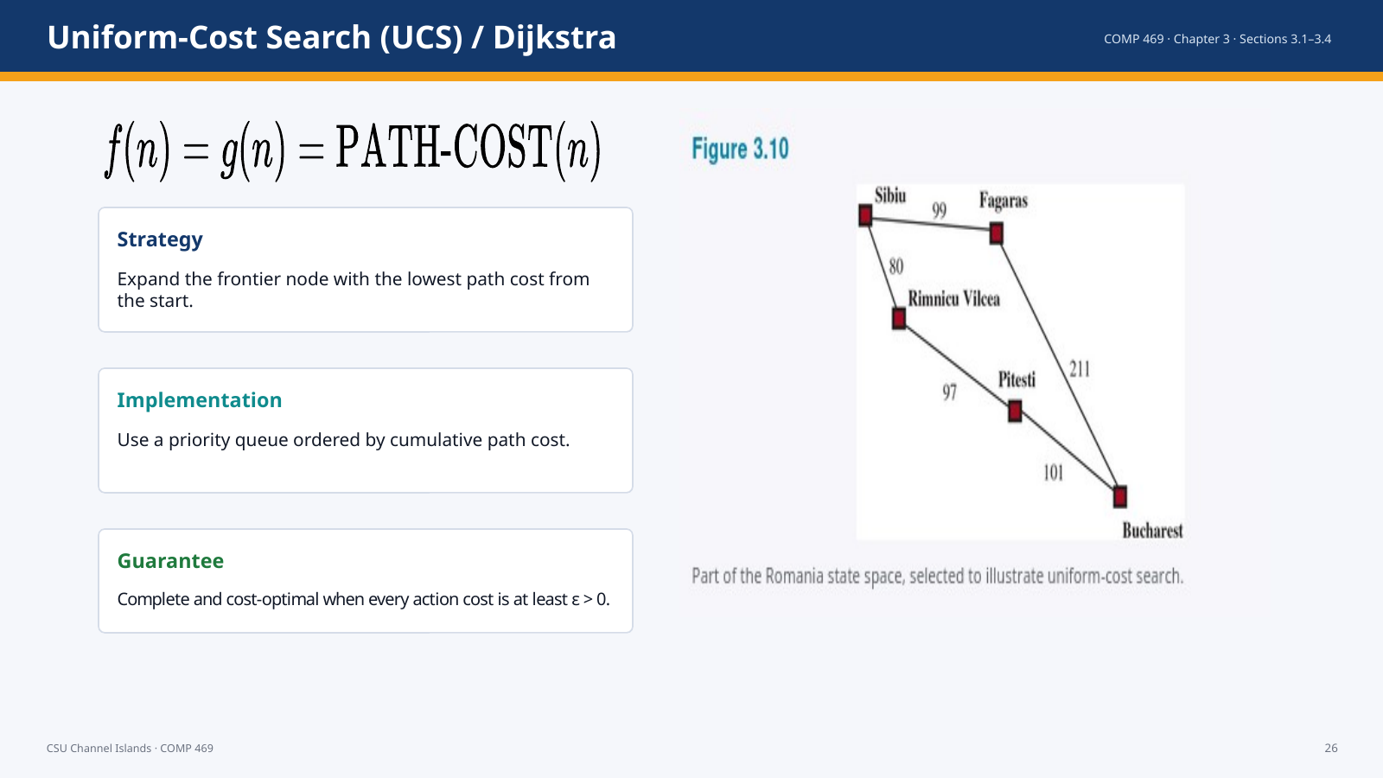 | Suggested time: 3–6 minutes  Teaching purpose: Explain UCS as path-cost best-first search.  Source alignment: AIMA Chapter 3, Sections 3.1–3.4; formulas and figures checked against the uploaded ODT file.

Read-aloud teaching script
Uniform-cost search is best-first search where the evaluation function is the path cost from the root to the node. In AI this is called uniform-cost search; in theoretical computer science it is associated with Dijkstra’s algorithm. It expands in waves of increasing path cost rather than increasing depth. This is the correct method when actions have different costs. The algorithm is complete and cost-optimal as long as every action cost is bounded below by some positive epsilon.
Teaching cue: Stress that UCS tests for goal when the node is selected for expansion, not merely when generated.

Transition: The next slide shows why that goal-test timing matters.

Slide 27 — UCS Example: Sibiu to Bucharest
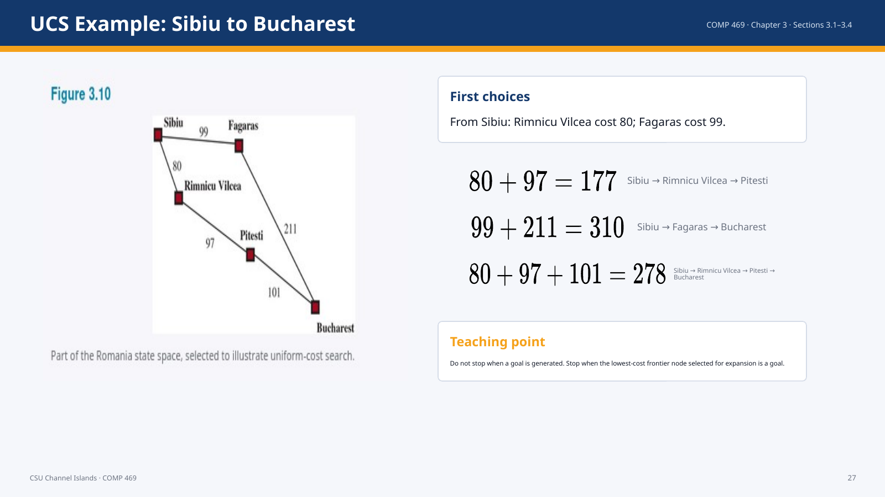 | Suggested time: 3–6 minutes  Teaching purpose: Walk through the textbook route-cost example and the late goal test.  Source alignment: AIMA Chapter 3, Sections 3.1–3.4; formulas and figures checked against the uploaded ODT file.

Read-aloud teaching script
From Sibiu, Rimnicu Vilcea has cost 80 and Fagaras has cost 99. UCS expands Rimnicu Vilcea first because 80 is cheaper. Later, a path through Fagaras generates Bucharest with cost 310. But the algorithm should not stop there, because a cheaper path may still be waiting. It later finds Bucharest via Rimnicu Vilcea and Pitesti at cost 278. The correct stopping rule is to stop when the lowest-cost node selected for expansion is a goal, not when a goal first appears.
Teaching cue: Have students compare 310 and 278 explicitly.

Transition: Now we state the UCS complexity formula.

Slide 28 — UCS Complexity and the Positive-Cost Assumption
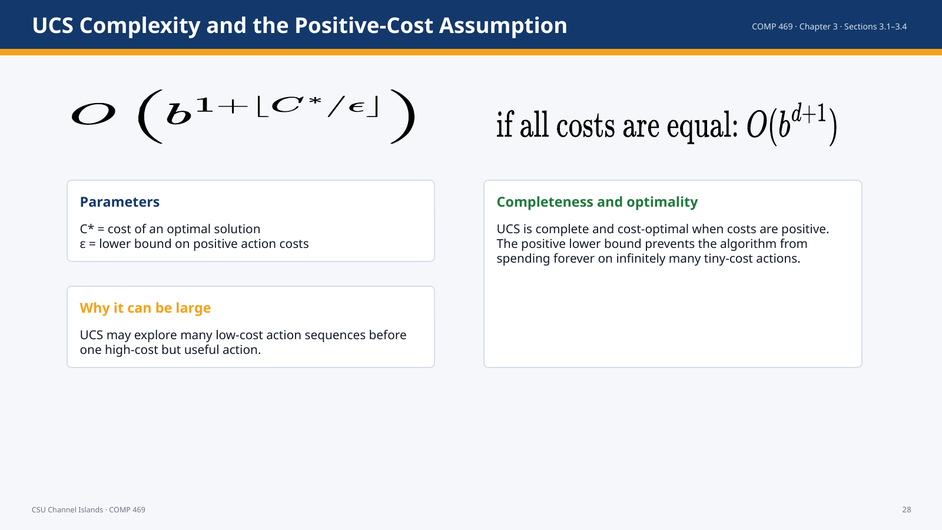 | Suggested time: 3–6 minutes  Teaching purpose: Display the UCS complexity formula correctly and explain its meaning.  Source alignment: AIMA Chapter 3, Sections 3.1–3.4; formulas and figures checked against the uploaded ODT file.

Read-aloud teaching script
Uniform-cost search complexity is characterized by the branching factor b, the optimal solution cost C star, and epsilon, the minimum positive action cost. The worst-case time and space are on the order of b raised to one plus the floor of C star divided by epsilon. This can be much greater than b to the d when many cheap actions exist. If all actions have the same cost, UCS behaves similarly to breadth-first search.
Teaching cue: This formula is one of the places where corrected math display matters.

Transition: Next we study depth-first search, which trades optimality for memory.

Slide 29 — Depth-First Search
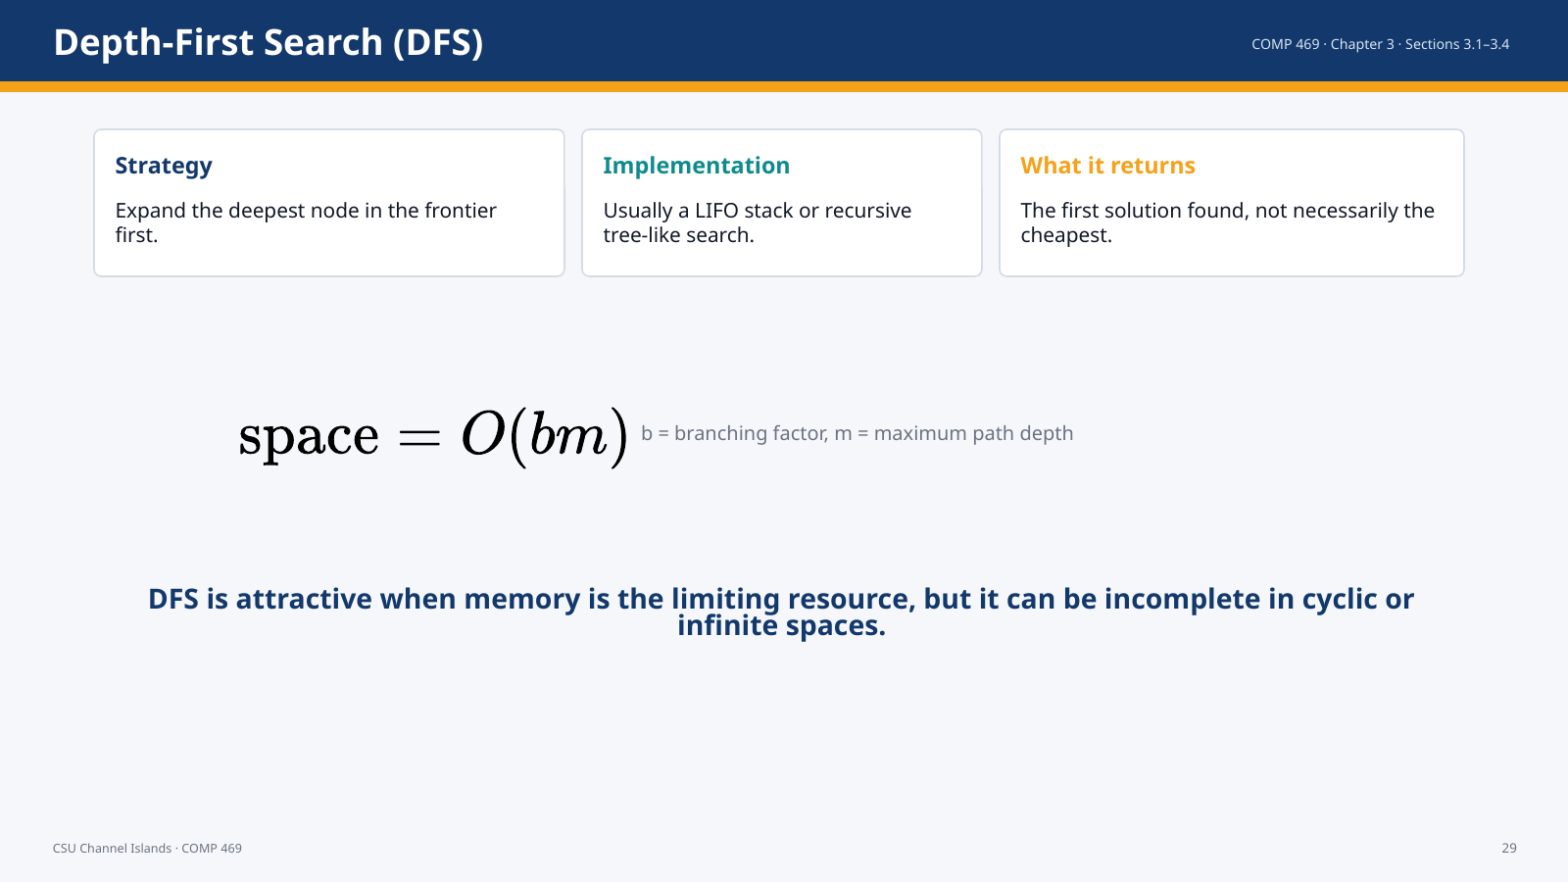 | Suggested time: 3–6 minutes  Teaching purpose: Explain DFS and its memory advantage.  Source alignment: AIMA Chapter 3, Sections 3.1–3.4; formulas and figures checked against the uploaded ODT file.

Read-aloud teaching script
Depth-first search expands the deepest node first, usually using a LIFO stack or recursion. It is not cost-optimal because it returns the first solution it encounters. Its main advantage is memory. For a finite tree-shaped state space, DFS memory can be O of b times m rather than exponential in the solution depth. That memory advantage is why depth-first style search appears in many AI areas.
Teaching cue: Contrast the BFS frontier as a surface with the DFS frontier as a narrow path.

Transition: The memory advantage comes with failure modes.

Slide 30 — DFS Failure Modes and Backtracking
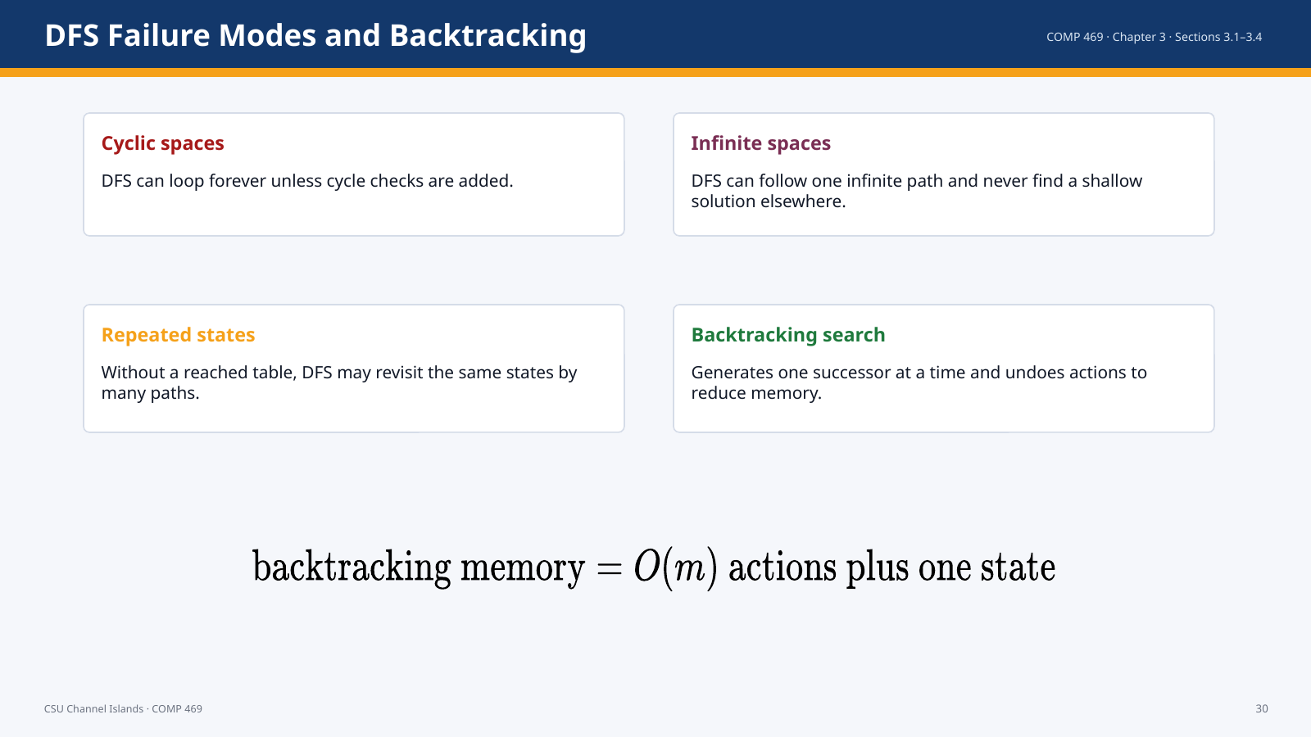 | Suggested time: 3–6 minutes  Teaching purpose: Explain why DFS is not generally complete and introduce backtracking.  Source alignment: AIMA Chapter 3, Sections 3.1–3.4; formulas and figures checked against the uploaded ODT file.

Read-aloud teaching script
DFS can be efficient in memory, but it is risky. In cyclic state spaces it can loop forever. In infinite spaces it can go down one infinite branch and never return. In acyclic finite spaces it can still revisit the same state by different paths. Backtracking search is a memory-efficient variant that generates one successor at a time and undoes actions when it backs up. This is important in later AI topics such as constraint satisfaction and logic programming.
Transition: Depth-limited search is one way to control DFS.

Slide 31 — Depth-Limited Search and Iterative Deepening
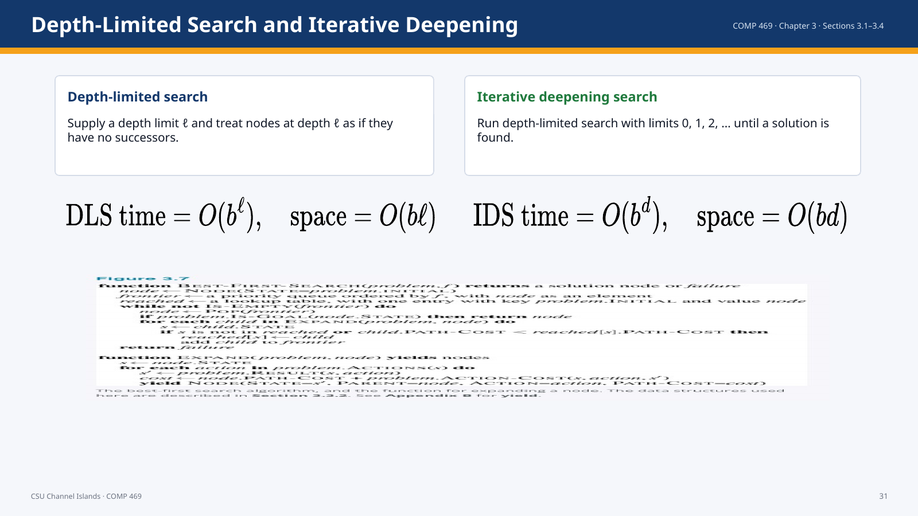 | Suggested time: 3–6 minutes  Teaching purpose: Present DLS and IDS formulas correctly.  Source alignment: AIMA Chapter 3, Sections 3.1–3.4; formulas and figures checked against the uploaded ODT file.

Read-aloud teaching script
Depth-limited search modifies depth-first search by imposing a limit ell. Nodes at depth ell are treated as if they have no successors. This prevents the algorithm from wandering forever, but if the limit is too small the algorithm misses the solution. Iterative deepening solves the problem of choosing ell by trying limits 0, 1, 2, and so on. It combines the memory advantage of DFS with the level-by-level discovery behavior of BFS.
Teaching cue: Use the Greek letter ell deliberately; students often confuse it with the number one.

Transition: The next slide shows why repeated work in IDS is acceptable.

Slide 32 — IDS Repetition
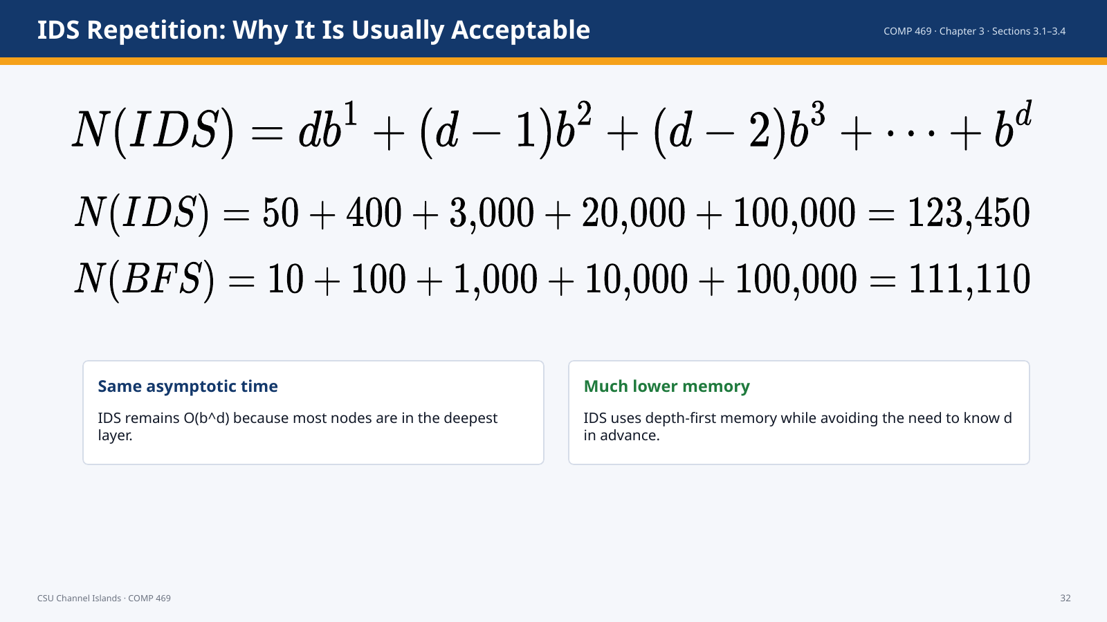 | Suggested time: 3–6 minutes  Teaching purpose: Show the IDS node-count formula and the b=10, d=5 comparison.  Source alignment: AIMA Chapter 3, Sections 3.1–3.4; formulas and figures checked against the uploaded ODT file.

Read-aloud teaching script
Iterative deepening repeats the upper levels of the tree, so it looks wasteful. But most nodes are at the deepest level. The exact formula weights shallow levels by how many times they are regenerated. In the example with b equals ten and d equals five, IDS generates 123,450 nodes while BFS generates 111,110. That is more work, but not dramatically more, and IDS uses far less memory. For large state spaces where memory is the limiting factor and the solution depth is unknown, IDS is often the preferred uninformed method.
Teaching cue: This slide uses the formulas from the ODT in clean mathematical form.

Transition: The final uninformed strategy in Section 3.4 is bidirectional search.

Slide 33 — Bidirectional Search
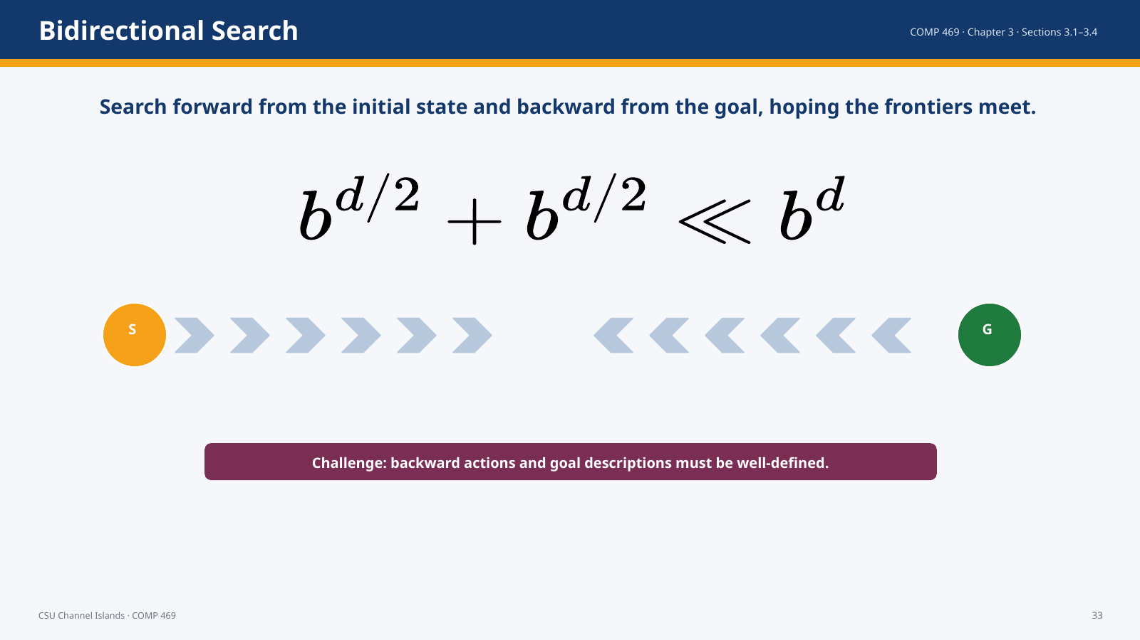 | Suggested time: 3–6 minutes  Teaching purpose: Explain the motivation and constraints of bidirectional search.  Source alignment: AIMA Chapter 3, Sections 3.1–3.4; formulas and figures checked against the uploaded ODT file.

Read-aloud teaching script
Bidirectional search searches forward from the initial state and backward from the goal, hoping the two searches meet. The motivation is mathematical. Two searches to depth d over two are much smaller than one search to depth d. However, bidirectional search requires the ability to reason backward from the goal and to detect when the frontiers meet. It is more straightforward when the goal is a specific state and actions are reversible or can be inverted.
Teaching cue: Use the equation to emphasize why the strategy can be powerful.

Transition: We finish by comparing the uninformed strategies.

Slide 34 — Comparing Uninformed Search Algorithms
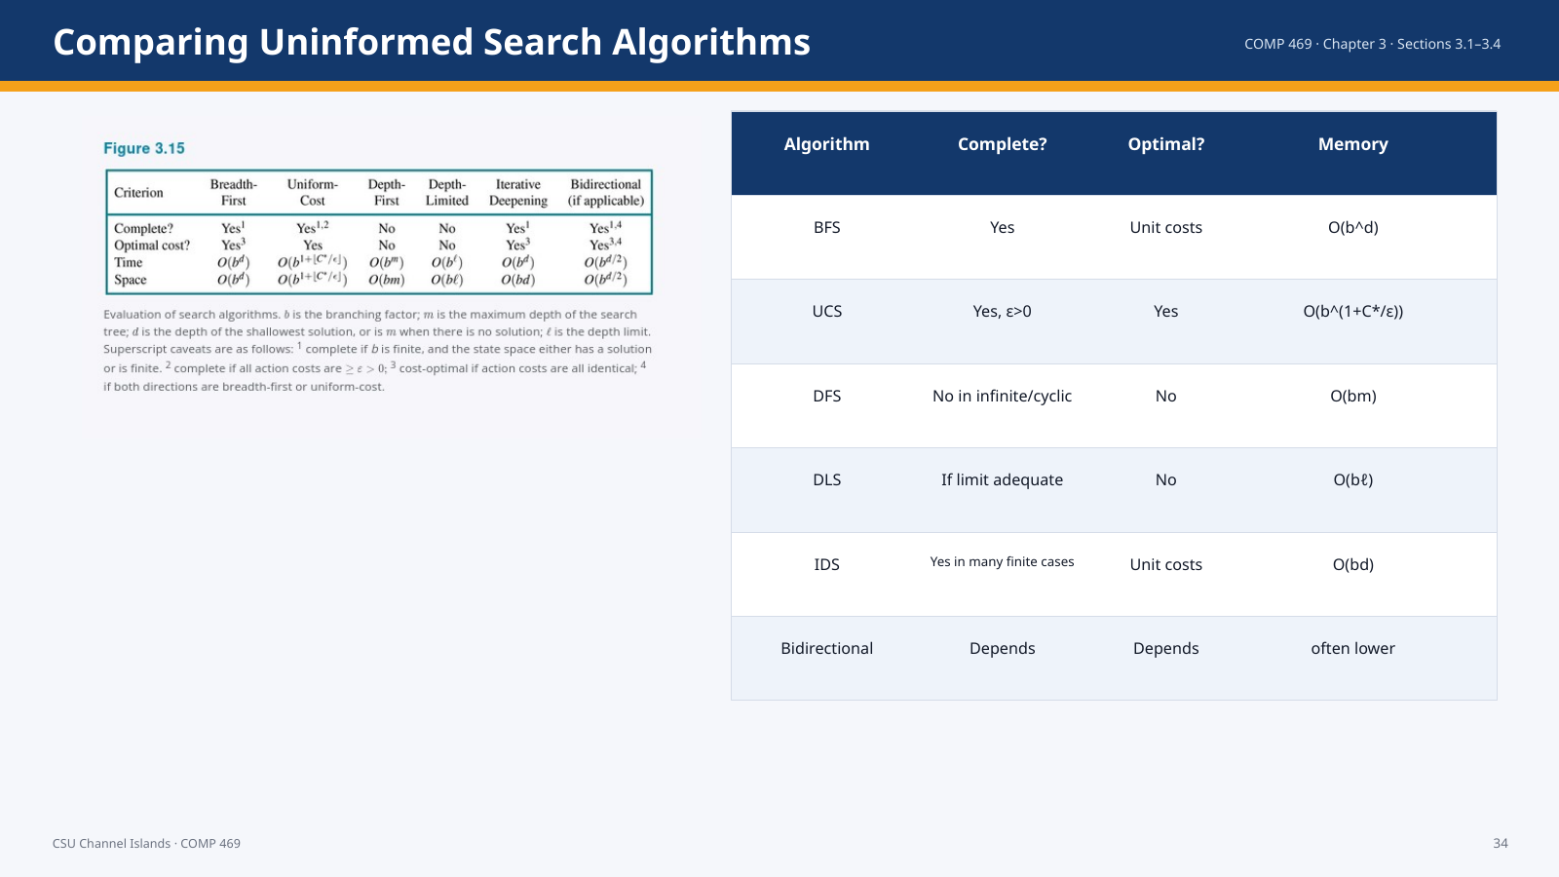 | Suggested time: 3–6 minutes  Teaching purpose: Summarize the tradeoffs in Section 3.4.  Source alignment: AIMA Chapter 3, Sections 3.1–3.4; formulas and figures checked against the uploaded ODT file.

Read-aloud teaching script
This comparison slide is the decision aid. Breadth-first search is complete and optimal for unit costs, but memory-expensive. Uniform-cost search is cost-optimal with positive costs but can be expensive. Depth-first search uses little memory but is not reliable in cyclic or infinite spaces. Depth-limited search controls DFS with a limit but depends on choosing a good limit. Iterative deepening combines the memory advantage of DFS with the level-order benefits of BFS and is often preferred when the depth is unknown. Bidirectional search can reduce depth dramatically when the problem permits backward search.
Teaching cue: Do not ask students to memorize every cell first; ask them to reason from the strategy and data structure.

Transition: The next slide gives a classroom demonstration plan.

Slide 35 — Class Demonstration: One Search Engine, Different Queues
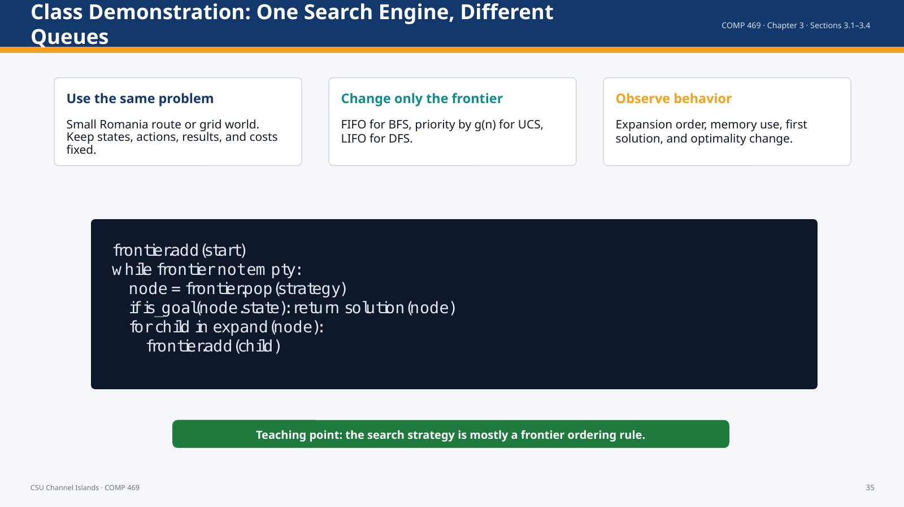 | Suggested time: 3–6 minutes  Teaching purpose: Provide a concrete live-demo plan tied to the deck.  Source alignment: AIMA Chapter 3, Sections 3.1–3.4; formulas and figures checked against the uploaded ODT file.

Read-aloud teaching script
For the live demonstration, use one small problem and keep the problem formulation fixed. The point is to change only the frontier behavior. With FIFO, the algorithm behaves like breadth-first search. With a priority queue ordered by g of n, it behaves like uniform-cost search. With LIFO, it behaves like depth-first search. Ask students to predict which node expands next and whether the first solution found is guaranteed to be optimal.
Teaching cue: If you have code available, show the one shared loop and swap the queue discipline.

Transition: Now we close with the main takeaways.

Slide 36 — Chapter 3.1–3.4 Takeaways
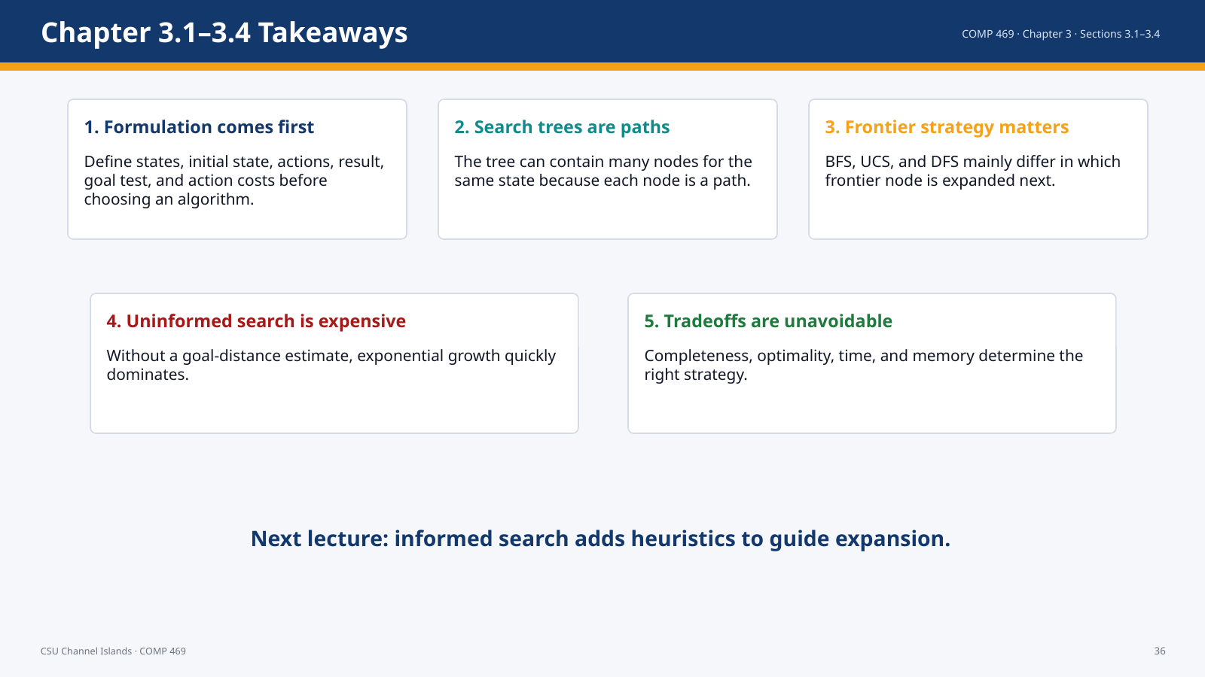 | Suggested time: 3–6 minutes  Teaching purpose: Close the lecture and bridge to informed search.  Source alignment: AIMA Chapter 3, Sections 3.1–3.4; formulas and figures checked against the uploaded ODT file.

Read-aloud teaching script
The main takeaways are these. First, problem formulation comes before algorithm selection. Second, a search tree represents paths, not merely states. Third, the frontier strategy determines the search behavior. Fourth, uninformed search can be complete and sometimes optimal, but it grows rapidly because it has no estimate of goal direction. Fifth, the appropriate algorithm depends on completeness, cost optimality, time, and space. In the next lecture, informed search adds heuristics so the agent can estimate which states appear closer to the goal.
Teaching cue: End with one check-for-understanding question: “When would UCS be better than BFS?”

Transition: End of lecture.

Quick Formula Reference
Path cost: cost = sum of c(s_i, a_i, s_{i+1}) along the path
Vacuum world: 2*2*2 = 8 for two cells; n*2^n for n cells
BFS: 1 + b + b^2 + ... + b^d = O(b^d); space O(b^d)
UCS: O(b^(1+floor(C*/epsilon))) when action costs are >= epsilon > 0
DFS: space O(bm) for finite tree-shaped state spaces
Depth-limited search: time O(b^ell), space O(b ell)
Iterative deepening: time O(b^d), space O(bd); N(IDS)=d b^1 + (d-1)b^2 + ... + b^d
Bidirectional search: b^(d/2)+b^(d/2) is much less than b^d

